# Application Setup

**Setup using docker- with FinalOneCommand docker branch:**

1. Install docker desktop and make an account
2. Open our project in VScode, open the terminal, and run:
3. docker-compose up --build

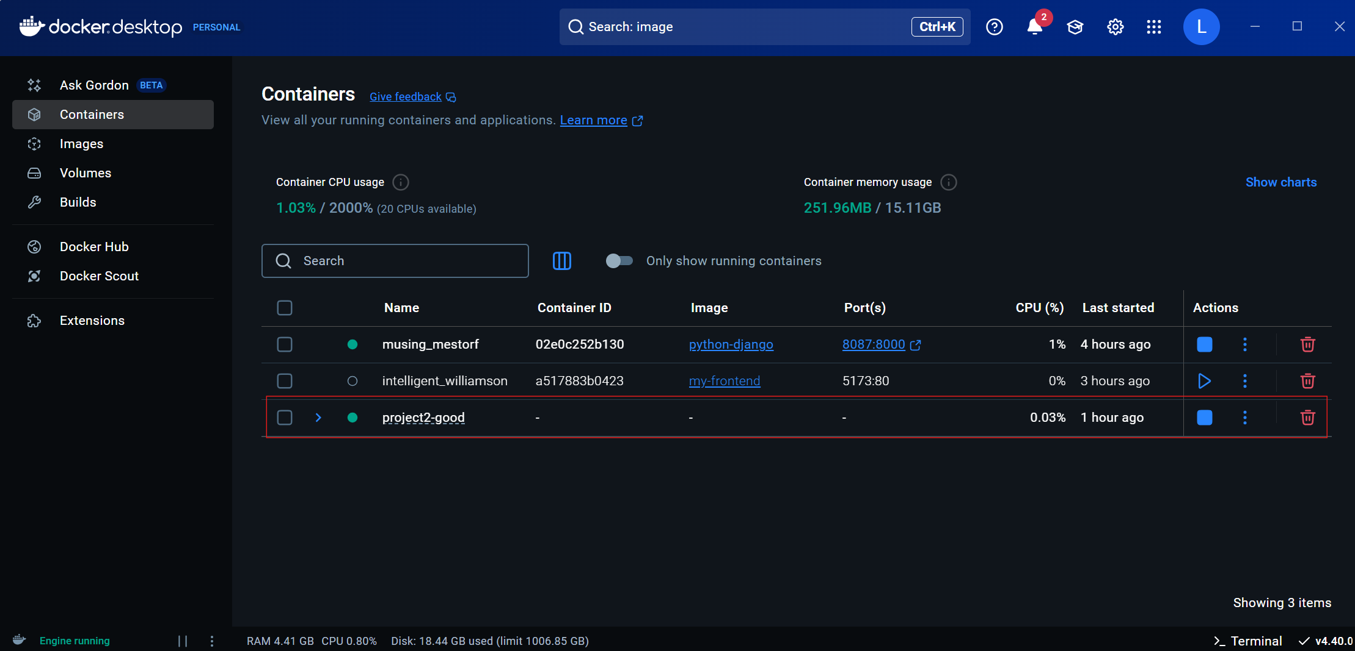

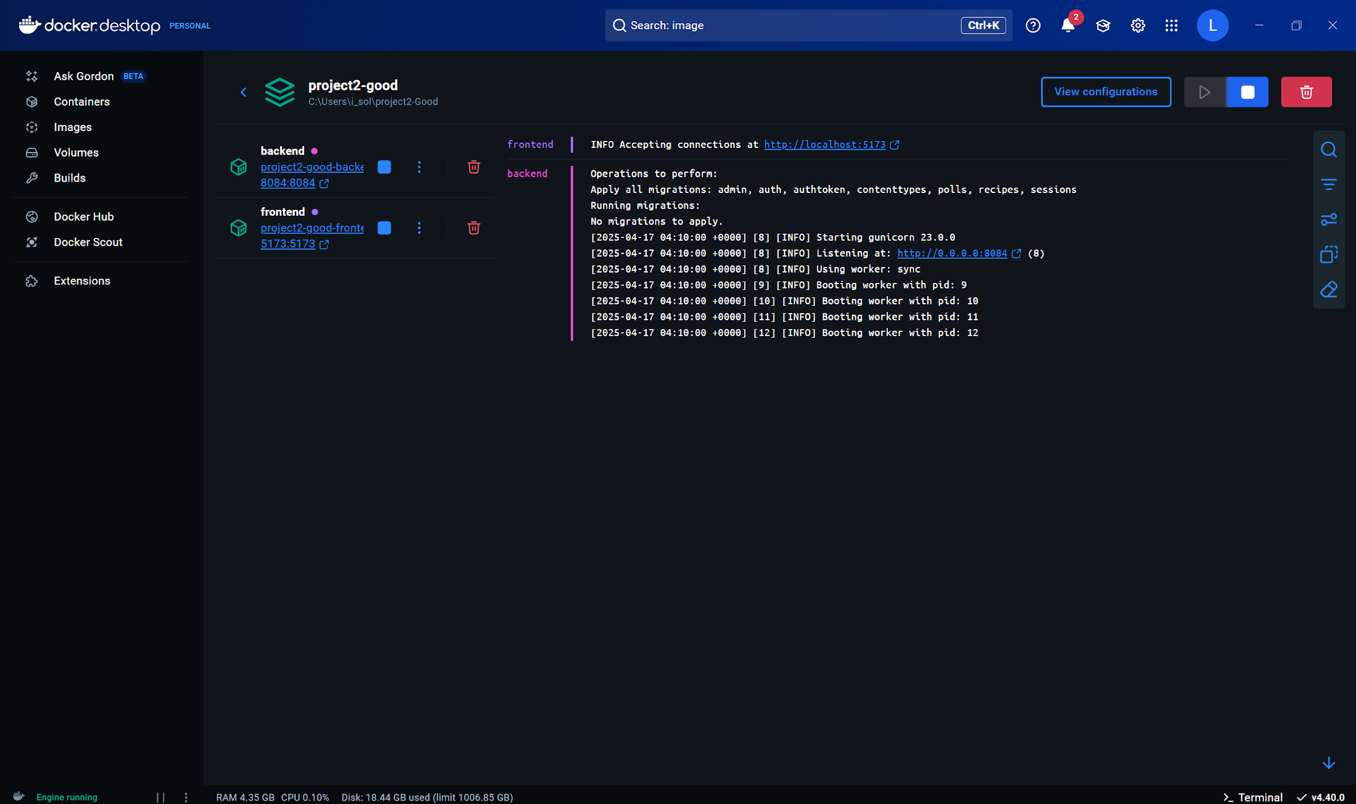

**2nd option using docker- with dockerizedFinal branch:**

**For backend- you can also find the commands in commands.txt:**

.\venv\Scripts\activate

docker build --tag python-django .

docker run -p 8084:8000 python-django

python manage.py runserver

**For frontend- you can also find the commands in frontendCommands.txt in the frontend folder:**

* Open a separate terminal while running the backend

.\venv\Scripts\activate

cd frontend

docker build -t my-frontend .

docker run -p 5173:80 my-frontend

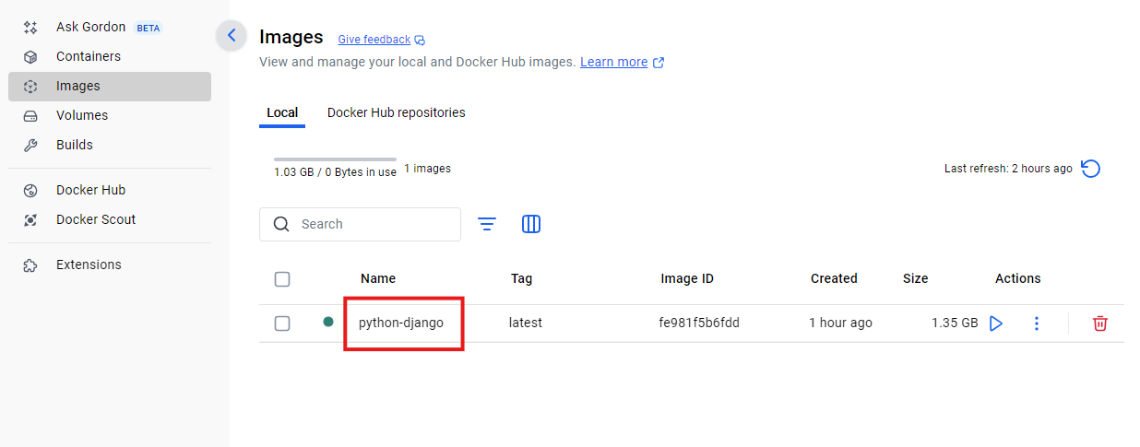

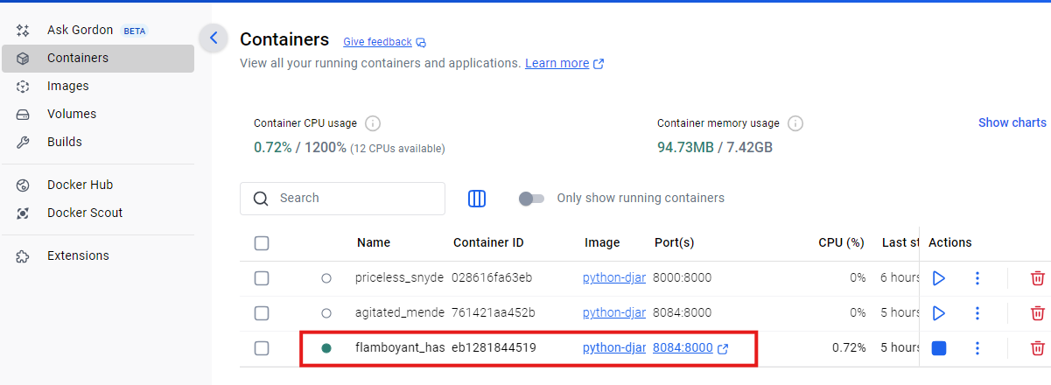

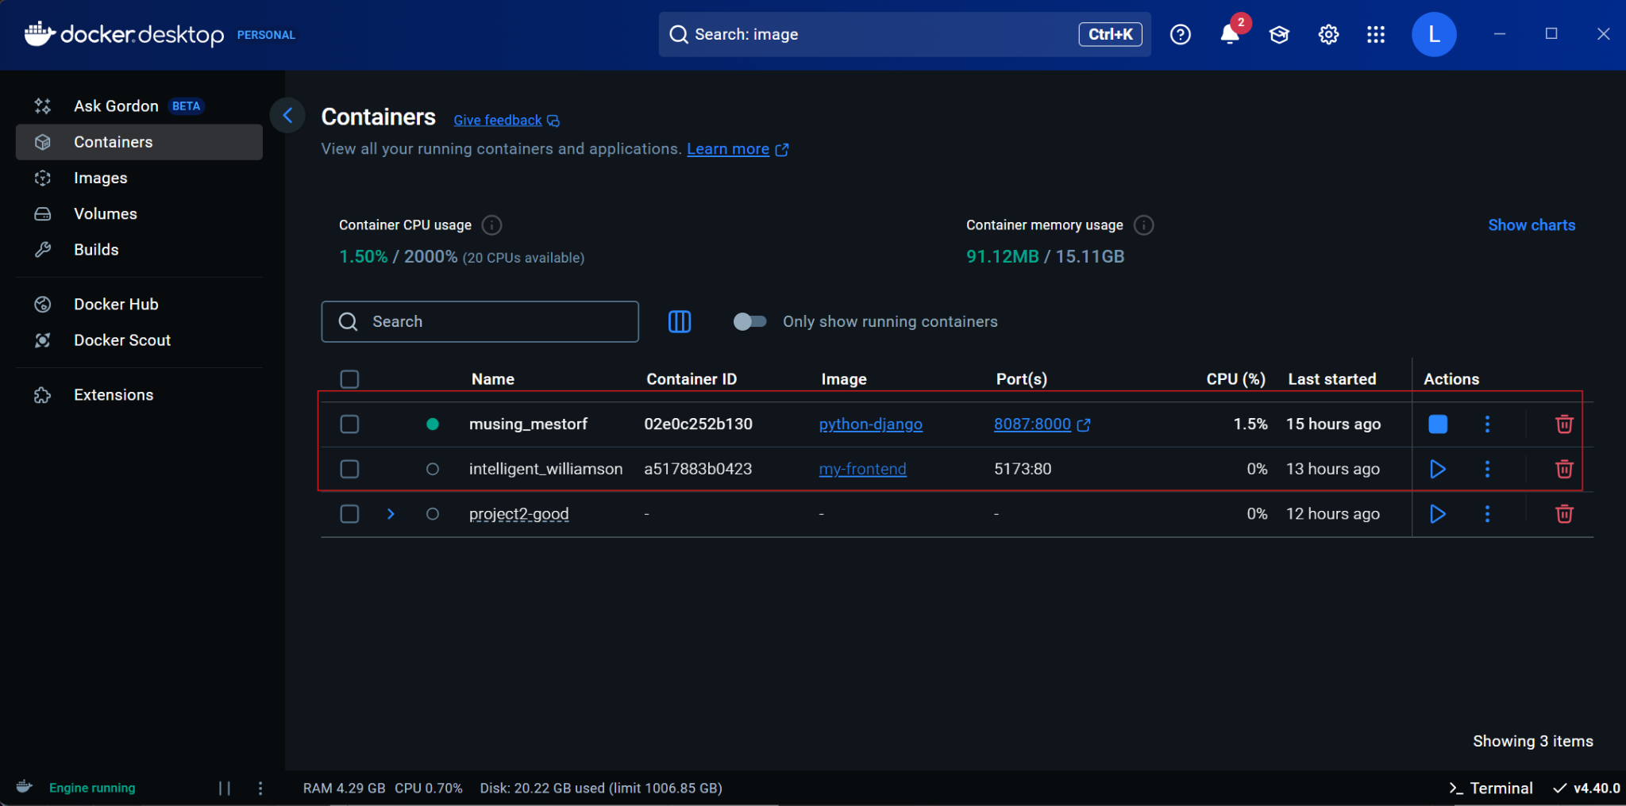

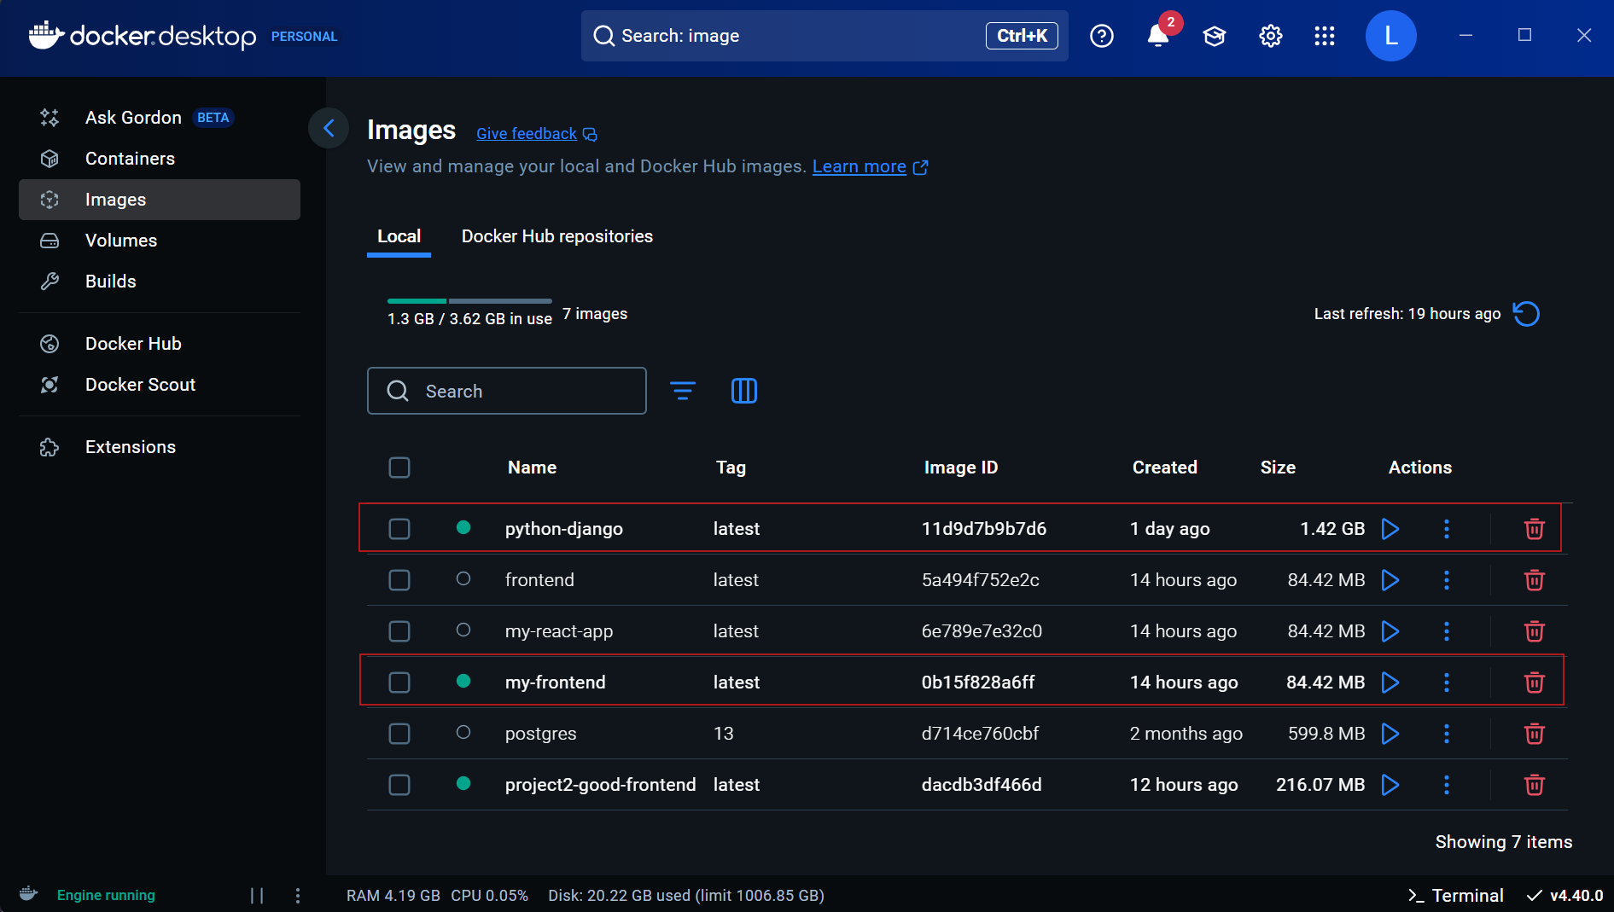

**Without docker:**

## Backend Setup:

* + Open a terminal and navigate to the root folder of the project.
  + Execute the command: python3 manage.py runserver 8084.
  + Note: The server must be run on port 8084, as it is specifically related to an endpoint.

## **Frontend Setup:**

* + Open a separate terminal.
  + Navigate to the frontend directory using the command: cd frontend.
  + Run the command: npm run dev to start the frontend development server.
  + The website will be accessible at localhost:5173

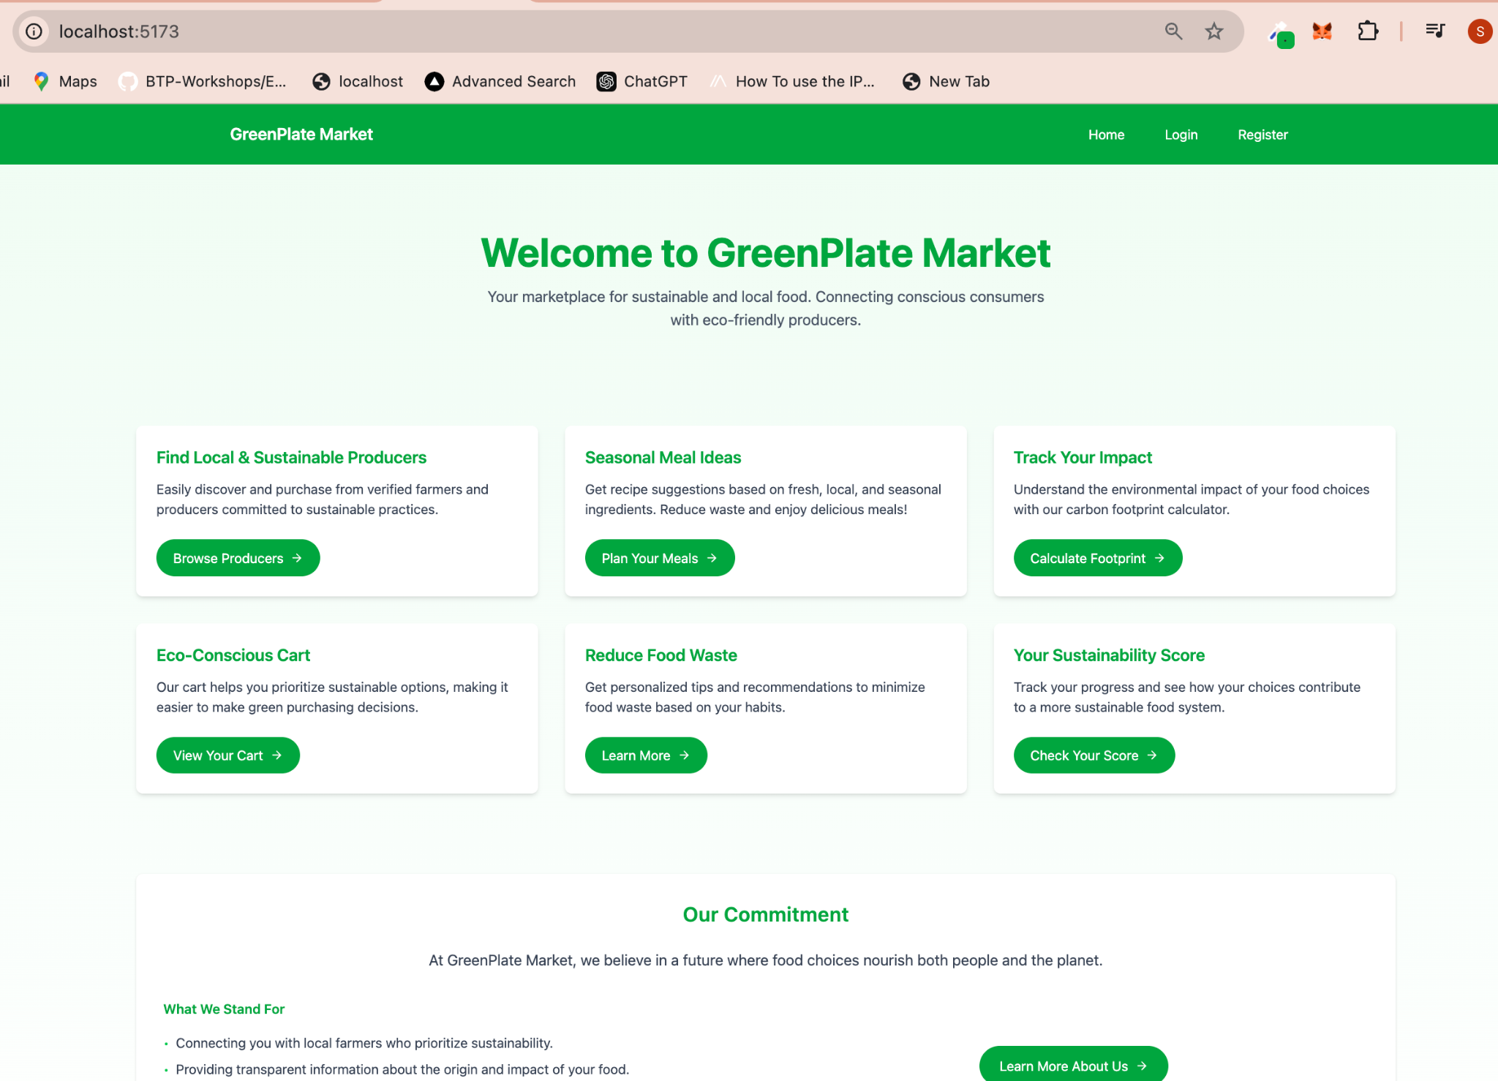

# **User Registration**

1. After completing the setup, navigate to the registration page.

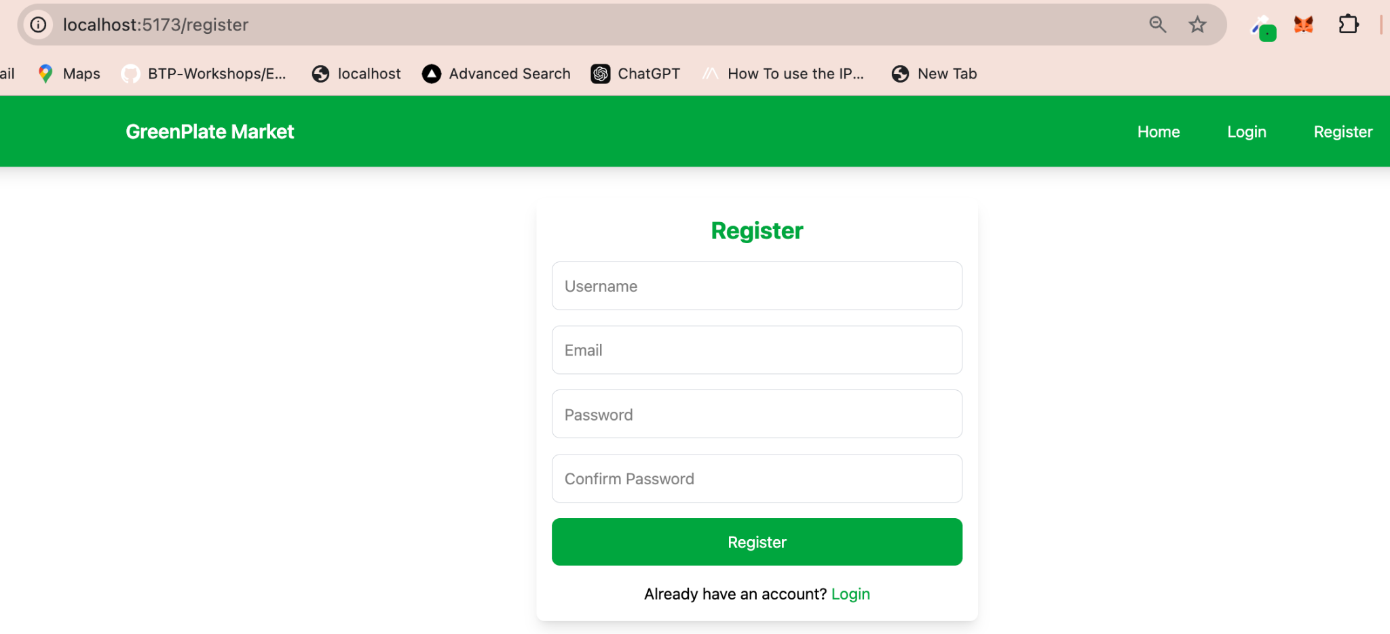

1. Fill in the required fields, including username, email, password, and confirm password.

# **Application Features**

Upon successful registration, the navigation bar will update to display the following features:

## **Ingredients:**

This section allows users to find seasonal ingredients and related recipes.

* + Users can input a location and season (e.g., "Quebec" and "Fall") to view a list of corresponding seasonal ingredients and recipes.

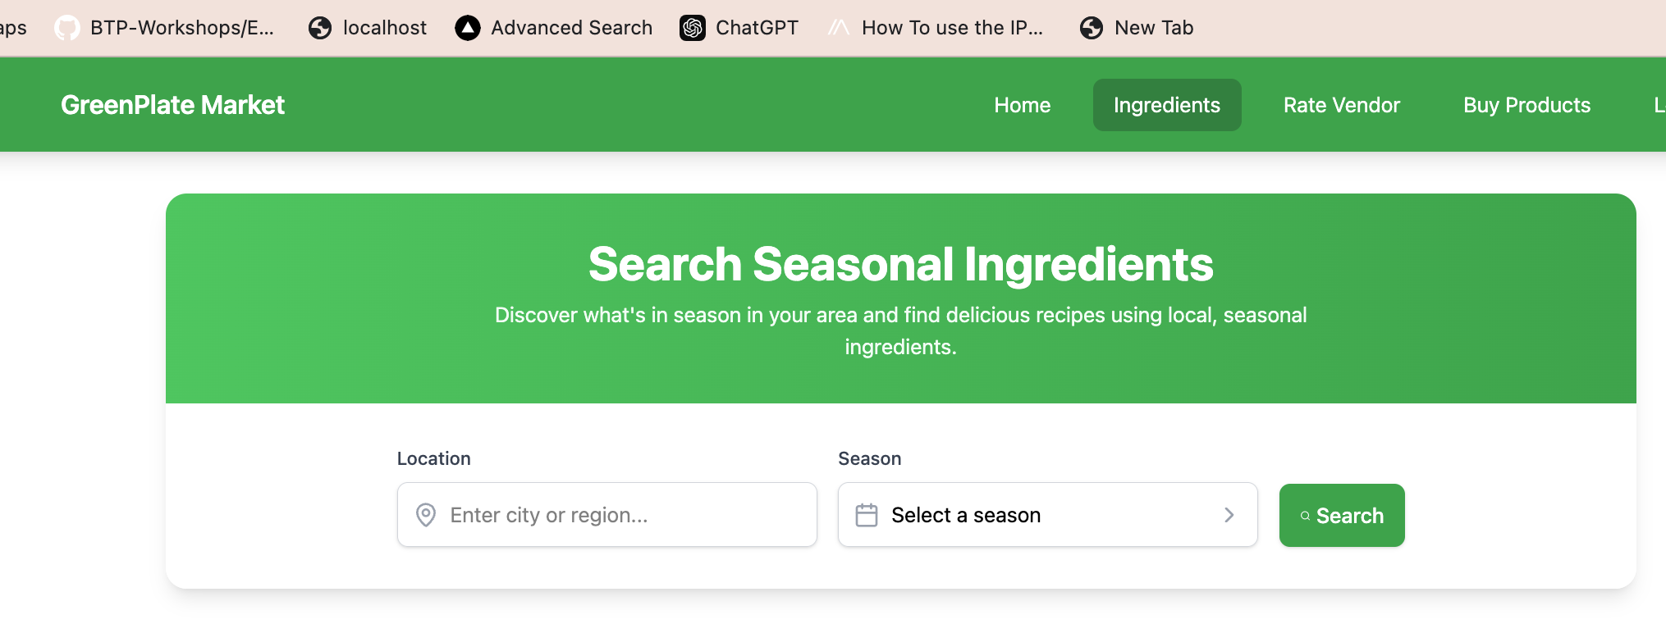

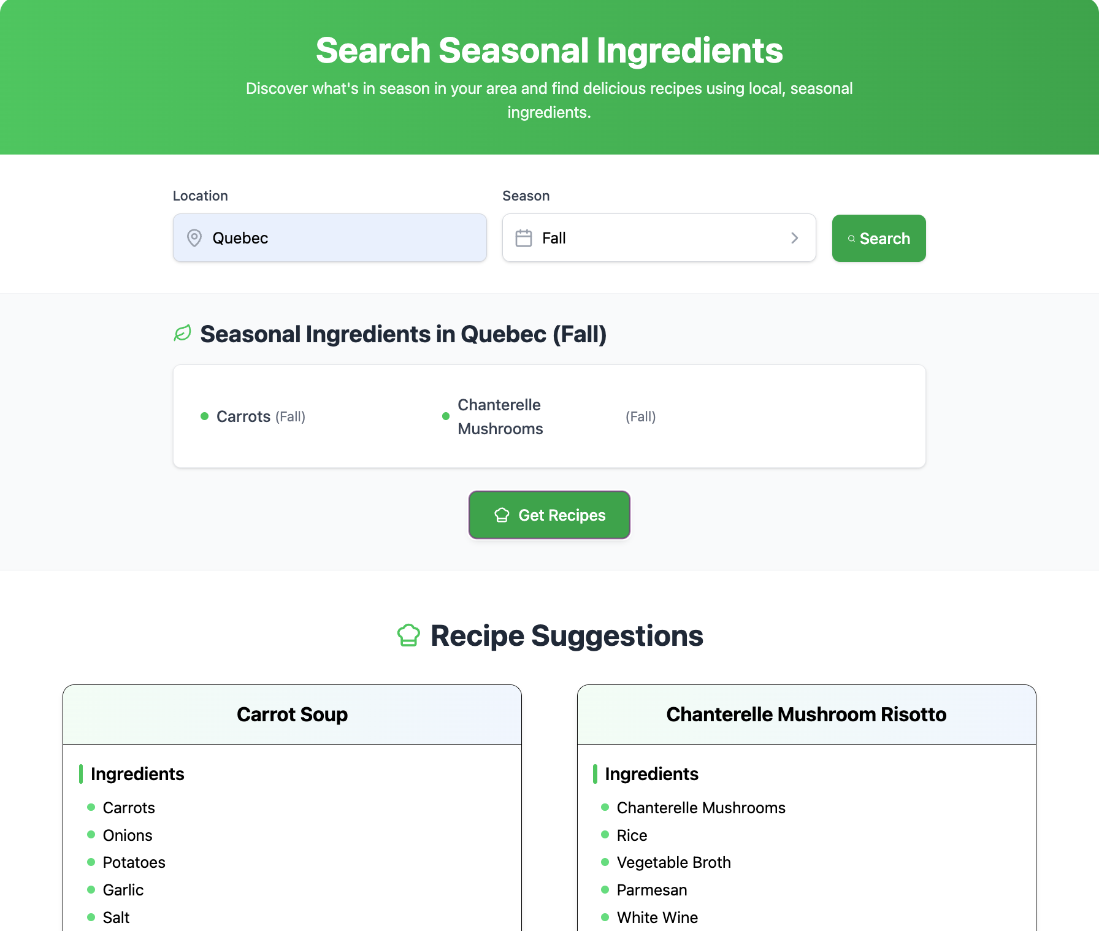

* If Users input a location and season (e.g., "Toronto" and "Fall") that does not exist in the database it throws and error message.

## **Rate Vendor:**

Users can rate vendors and provide reviews, which are then recorded in the database.

* 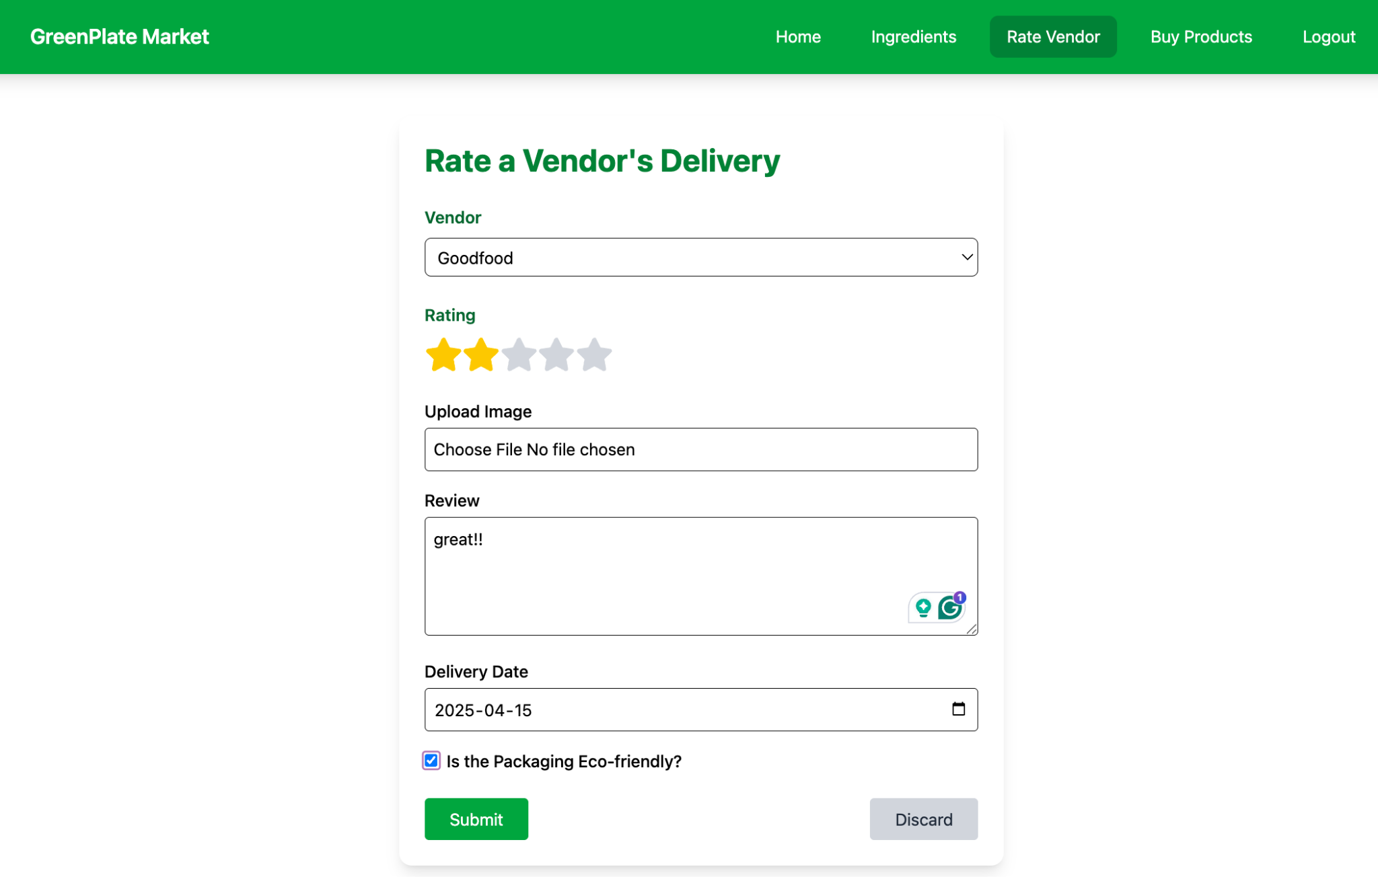

## **Buy Products:**

This section displays a list of available products.

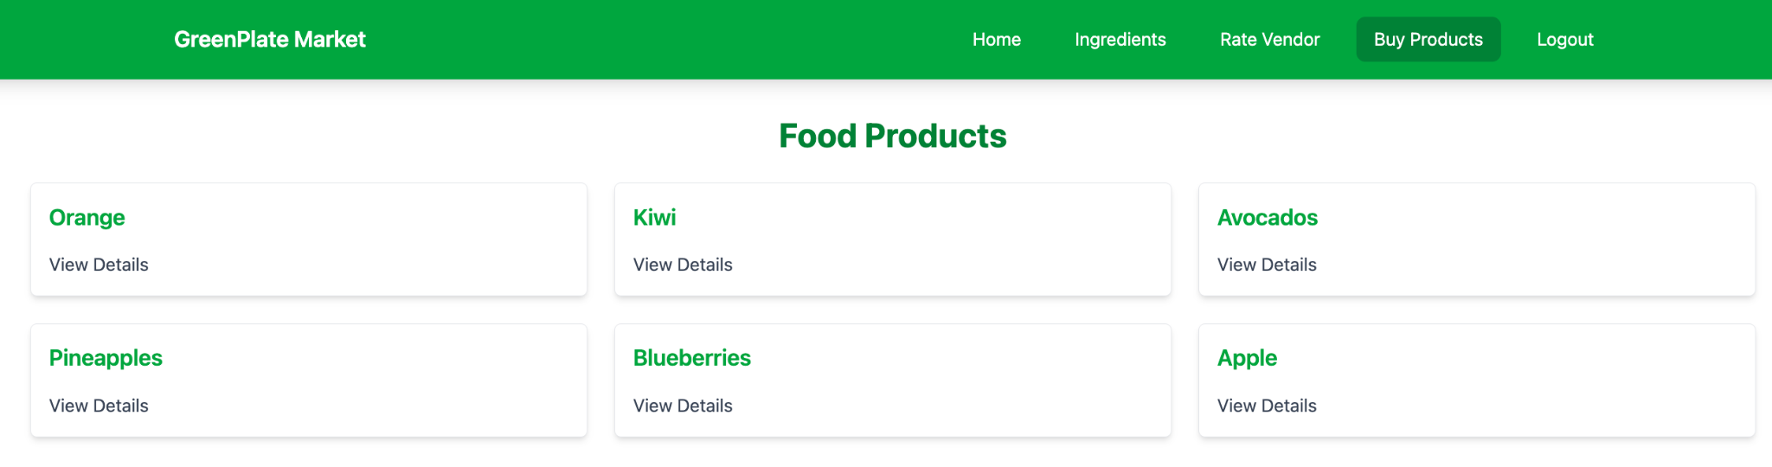

* + Users can view product details by clicking on the "View Details" option.

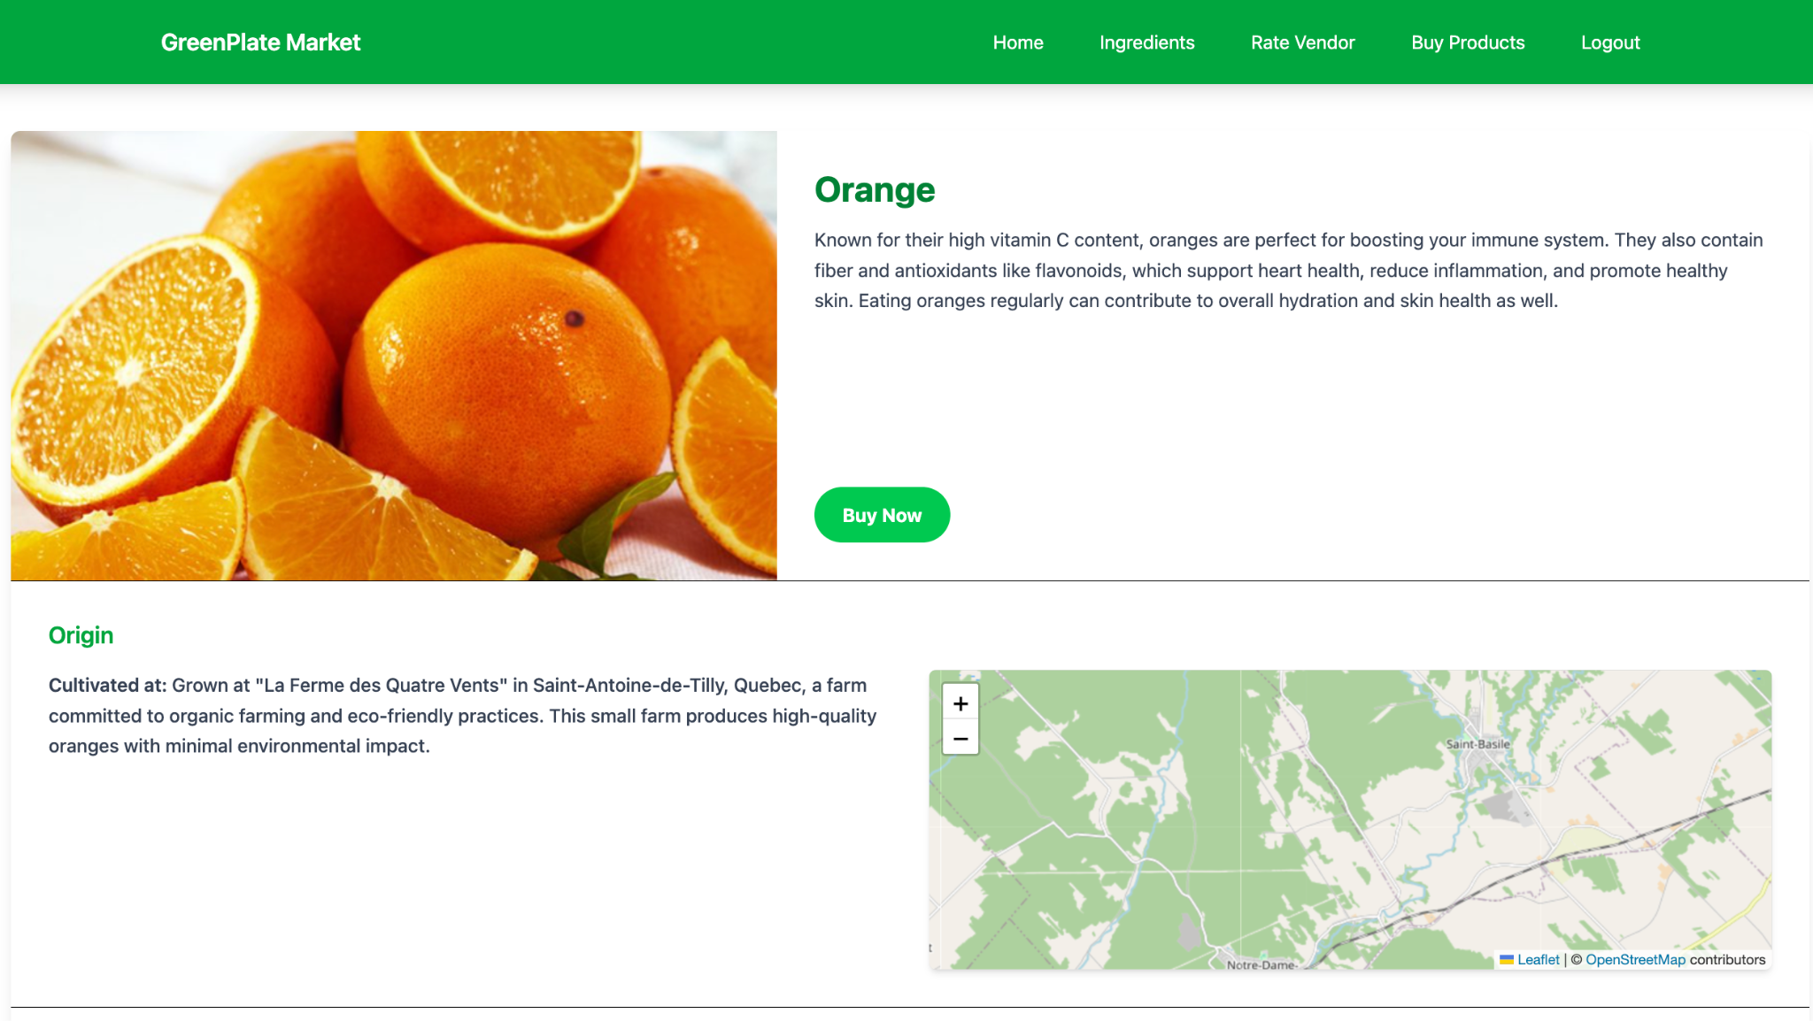

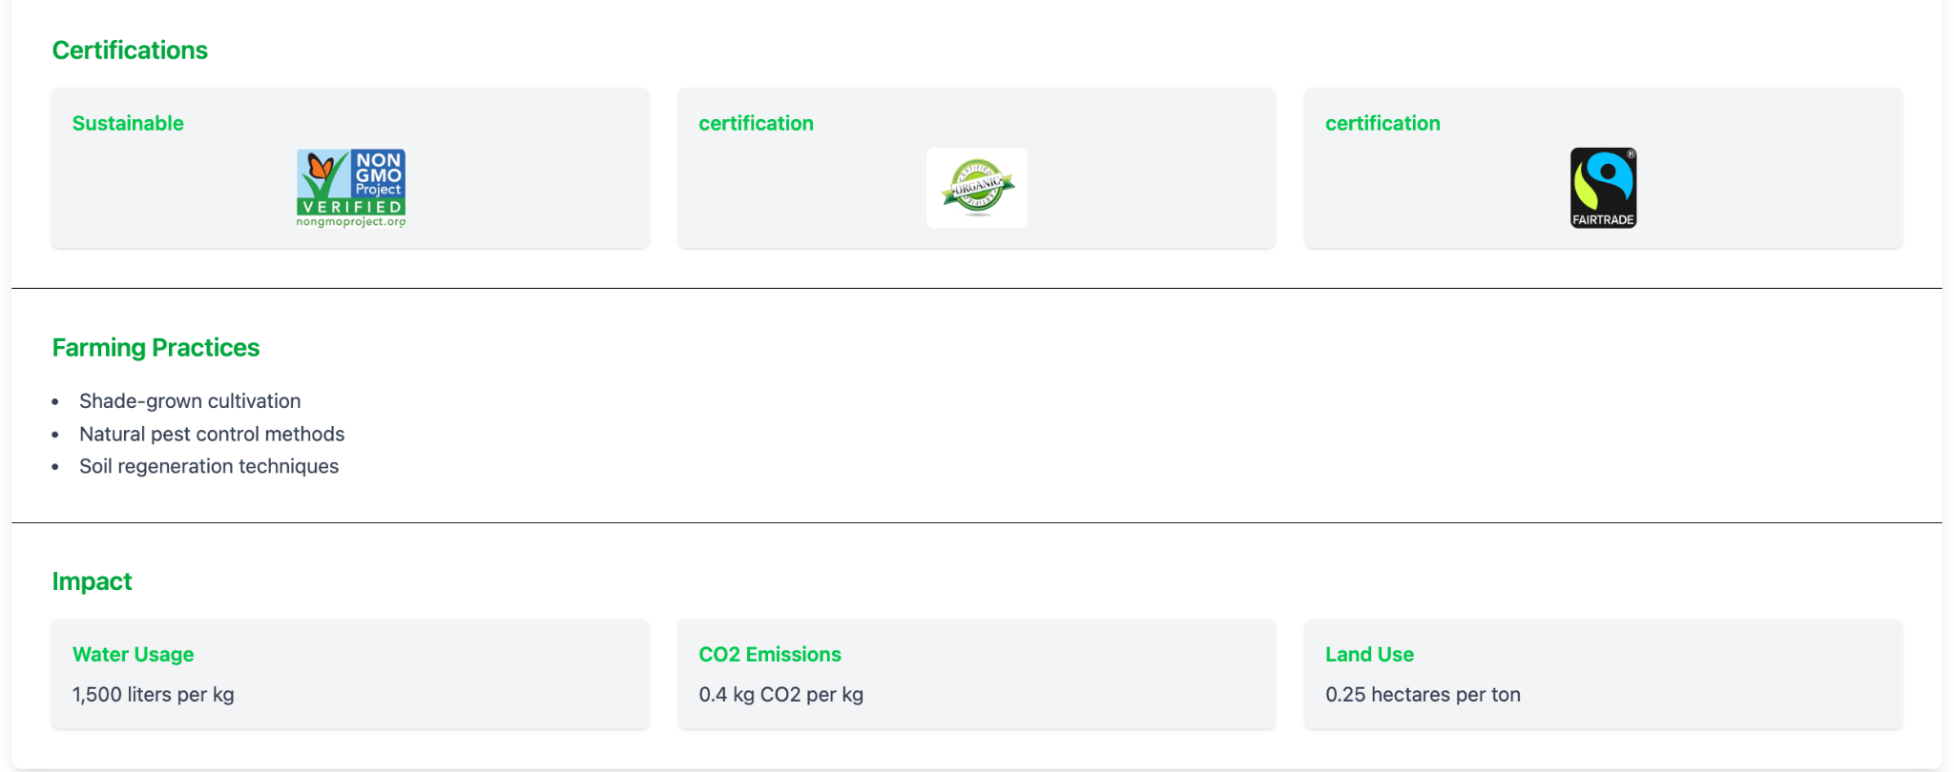

* + The "View Details" provides comprehensive product information, including origin, certification, impact, etc. It enables users to purchase the product by clicking the “Buy now” button.

# **Testing: How does it work?**

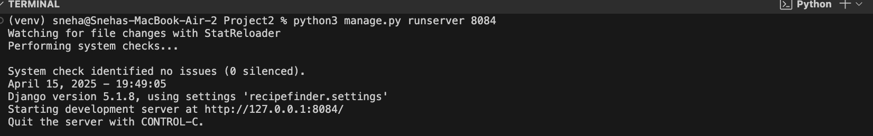

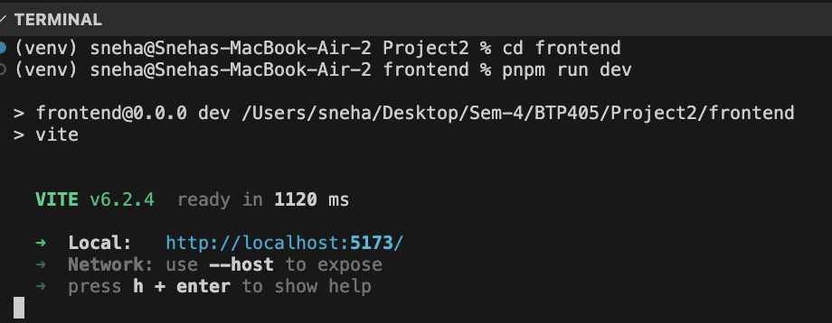

## **Registration:**

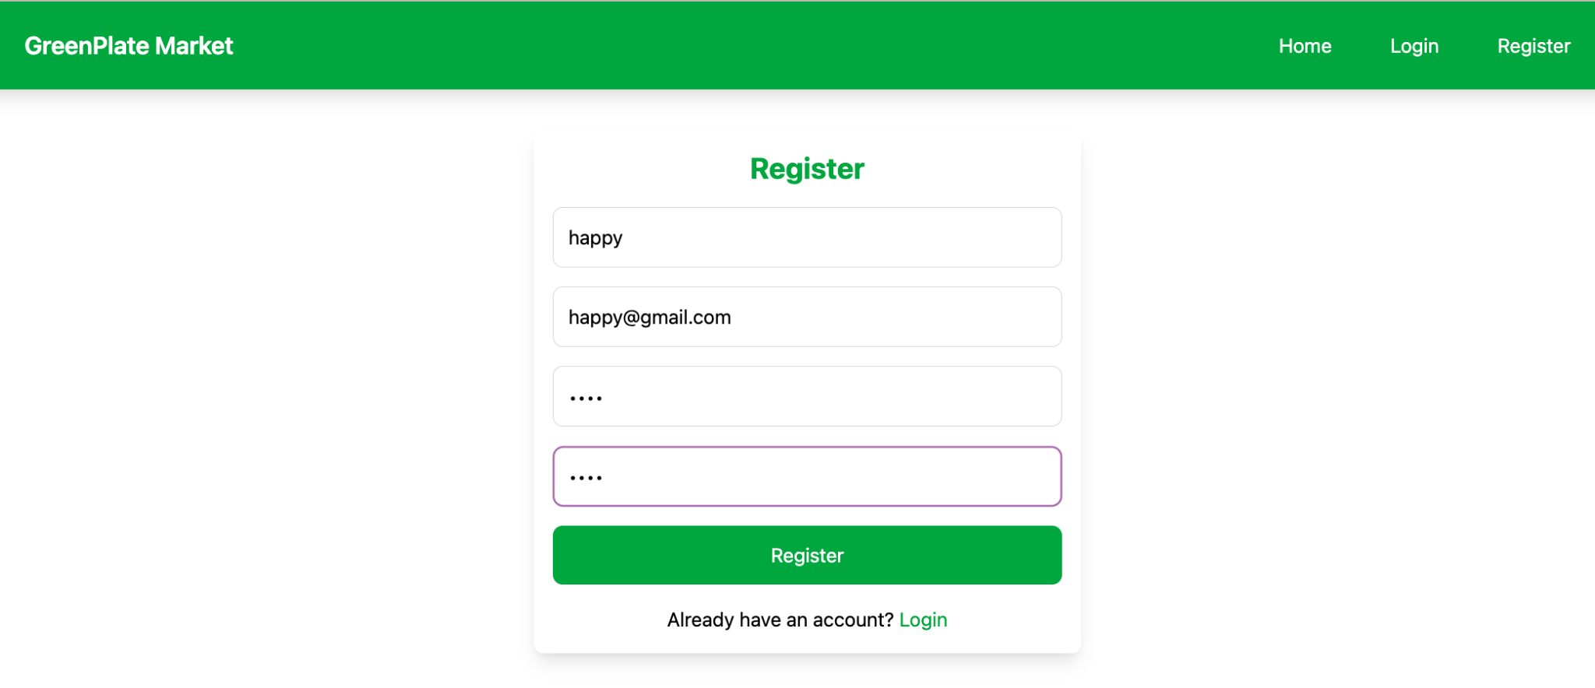

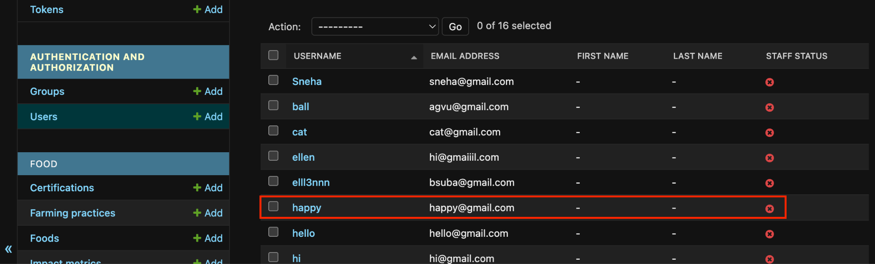

## **Ingredients:**

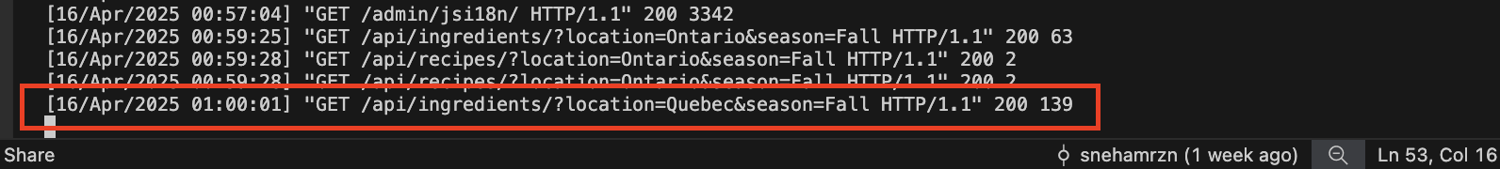

It gets fetched from the database.

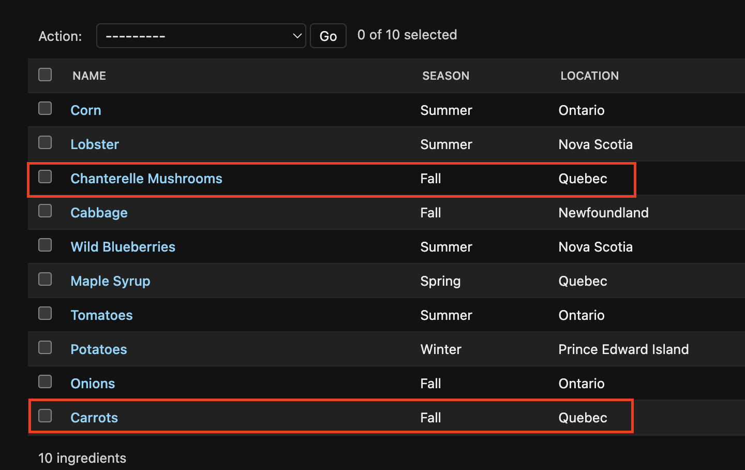

## **Rate the vendor**

It makes a post request and saves it in the database.

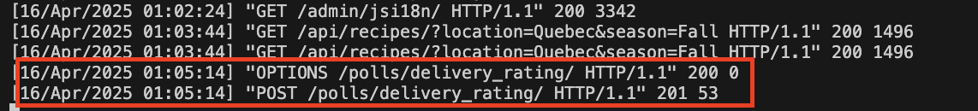

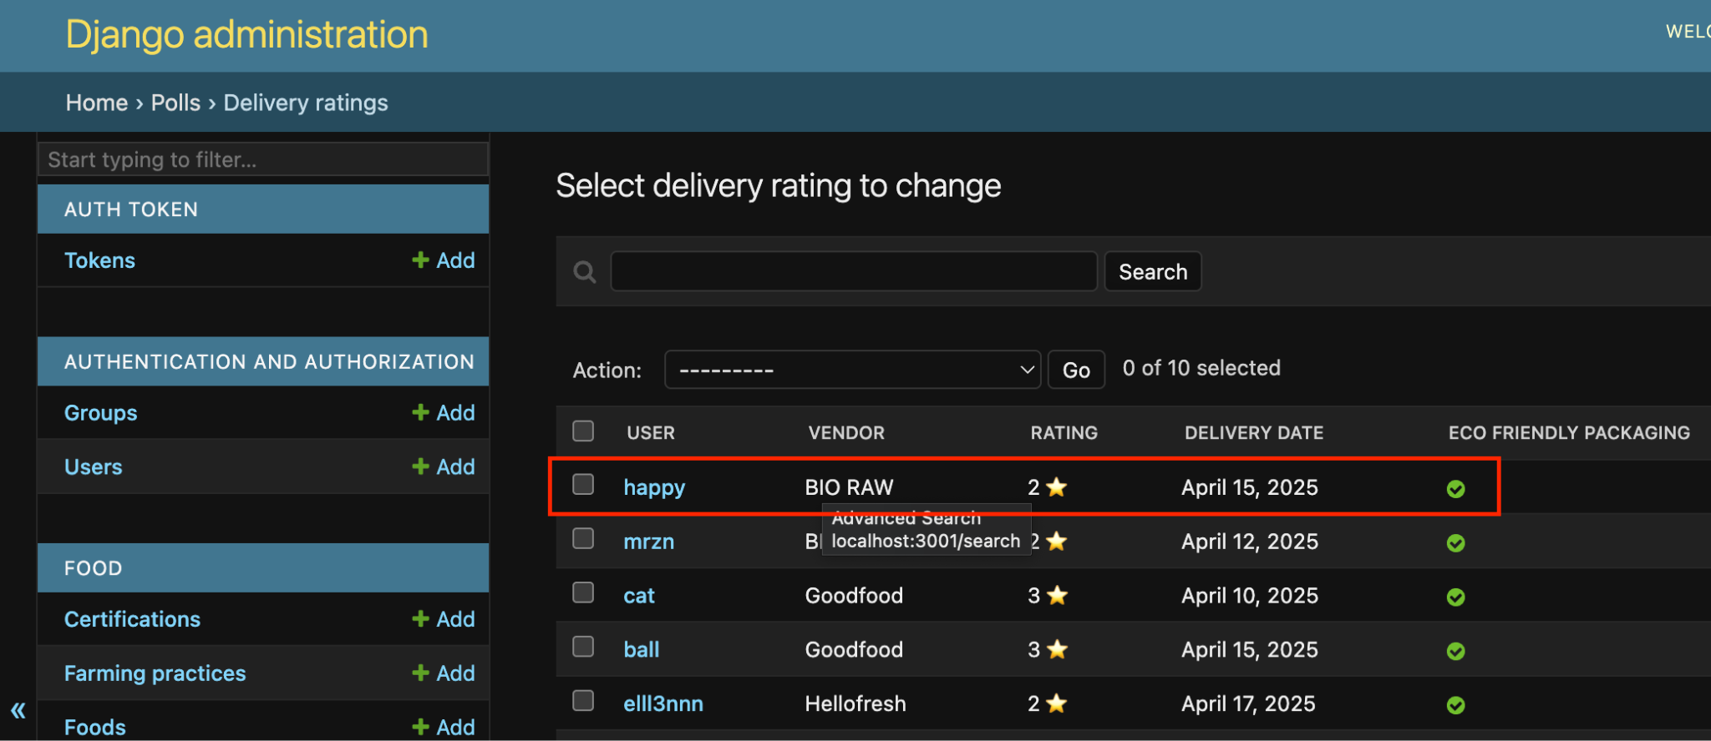

Run python manage.py test polls to test.

What does this test do:

* creates a test user and a test vendor
* creates a delivery rating object & sets all fields where the rating=4 and the saved vendor name=Goodfood
* checks if the rating is correctly saved as the value 4
* checks that the saved vendor name is indeed Goodfood
* The data is temporarily saved to the database during the test, and then deleted when the test ends

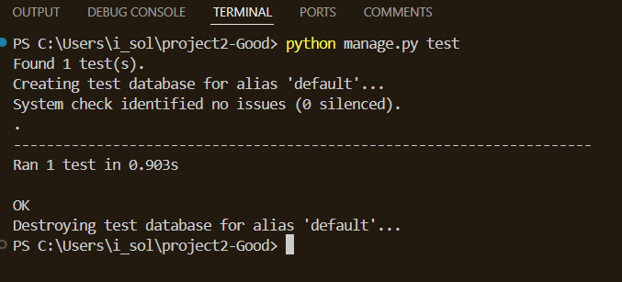

**To view the code go to: polls/tests.py**

## **Buy Products**

The data is fetched from the database, making a GET request.

And displays all the FoodProducts that are available.

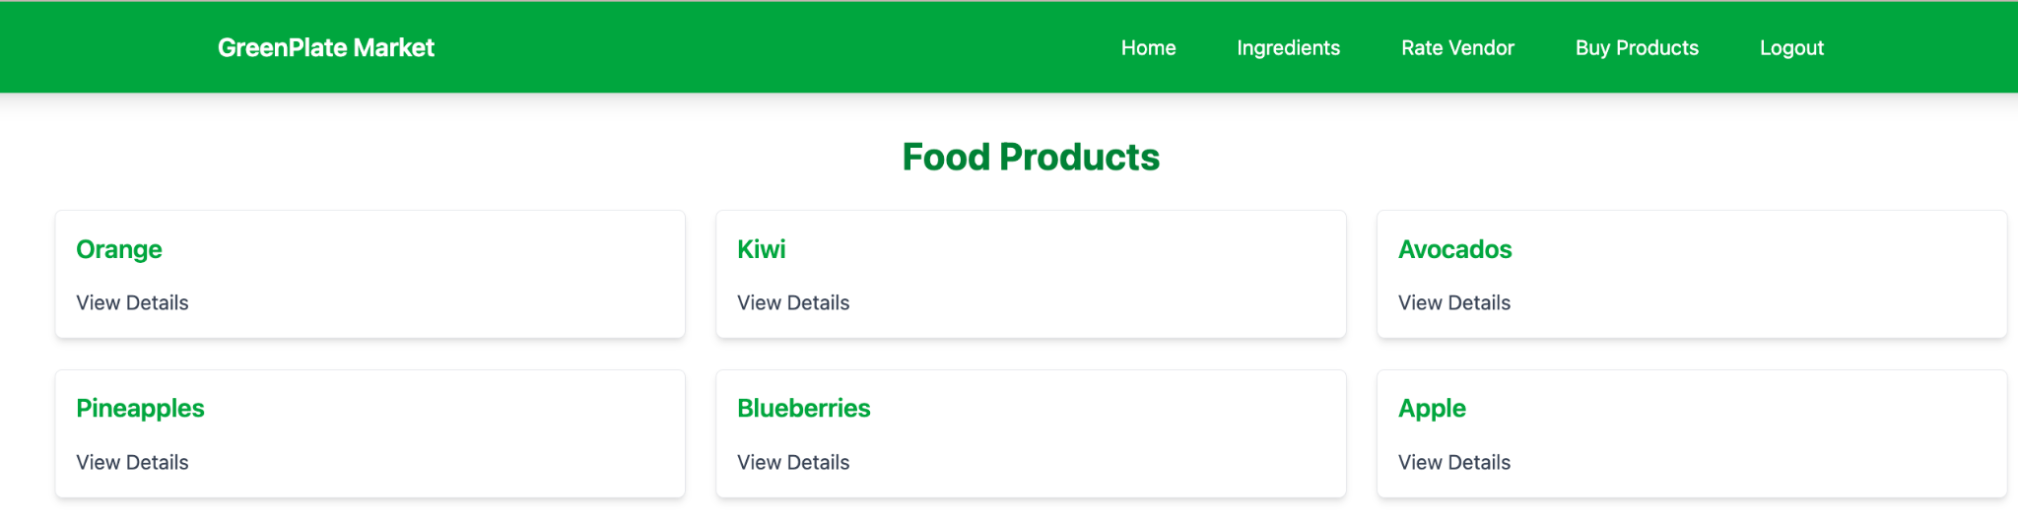

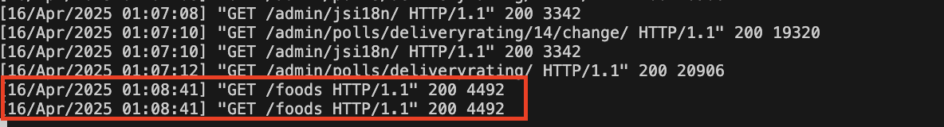

To view the details when we click on the “View details”. It shows details about that production, including origin location, CO2 emission, certification, impact, etc.

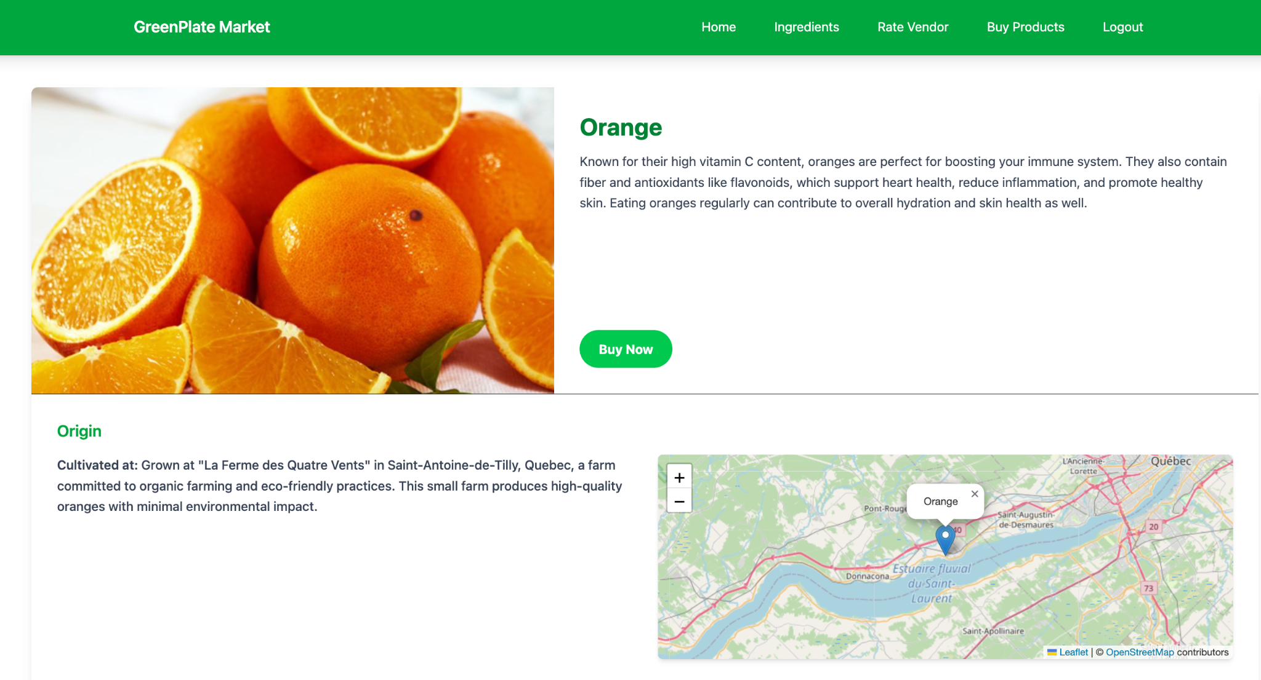

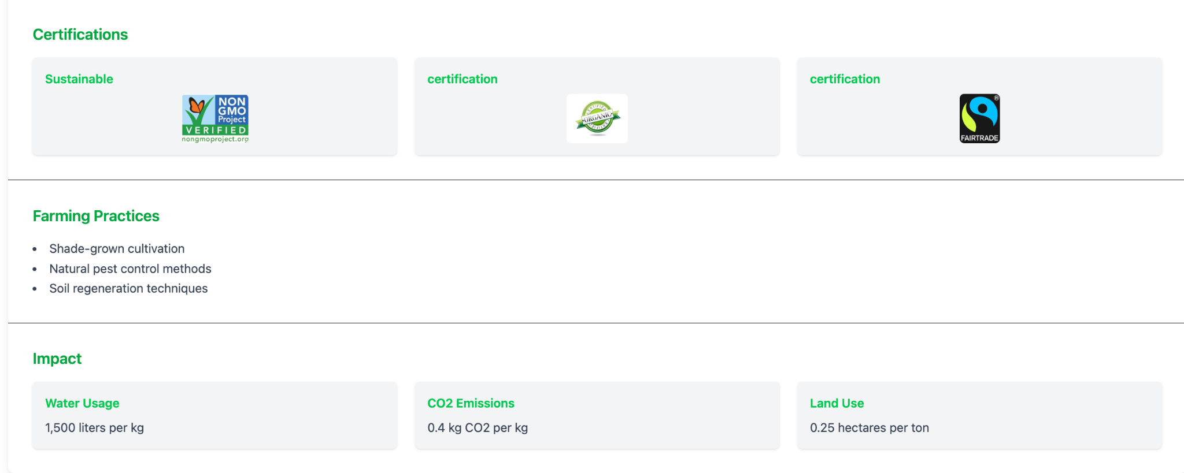

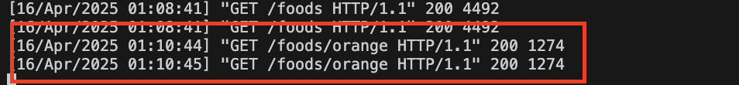

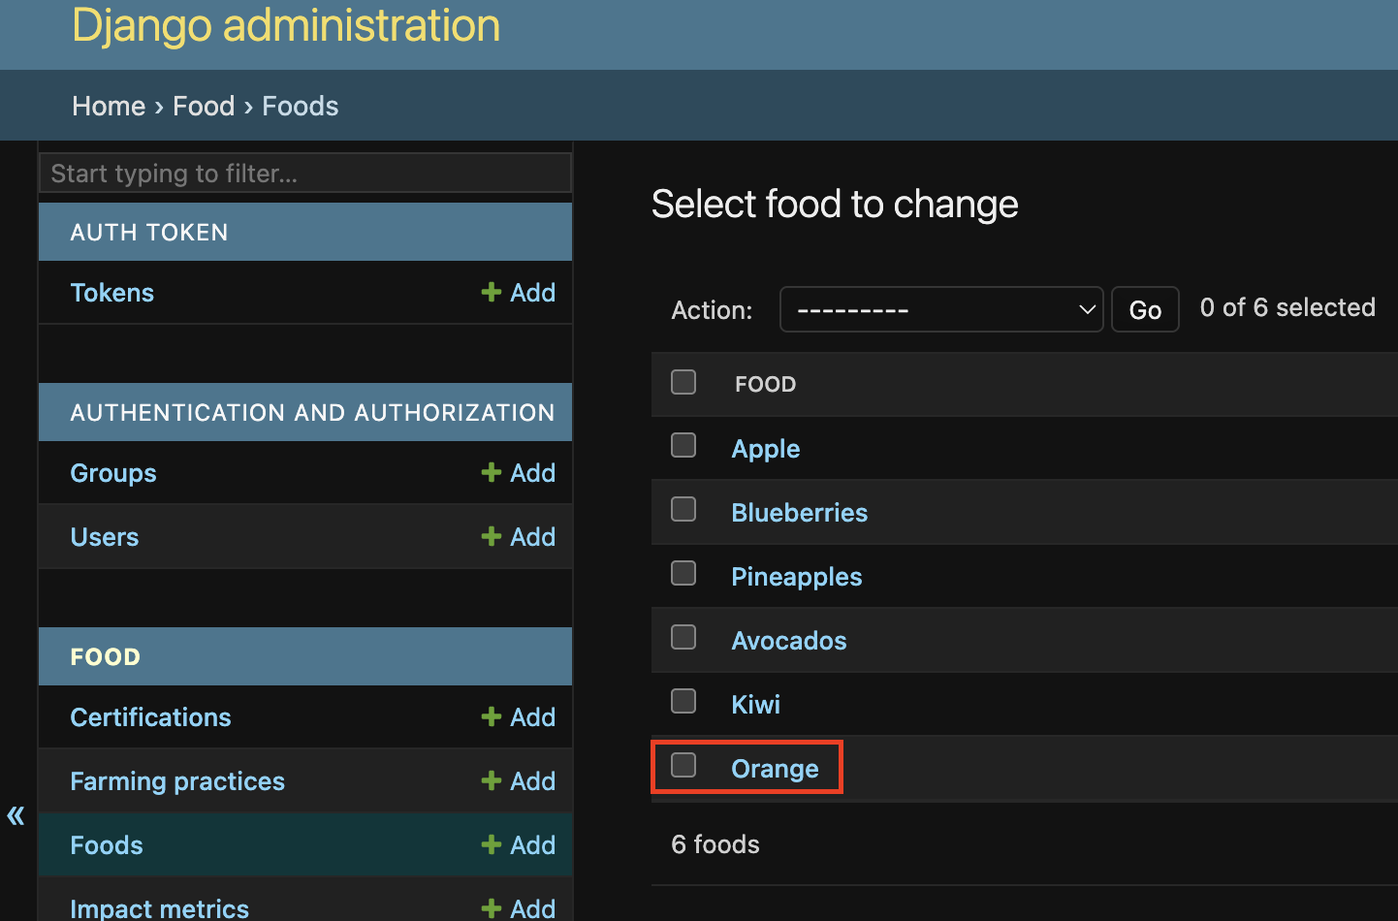

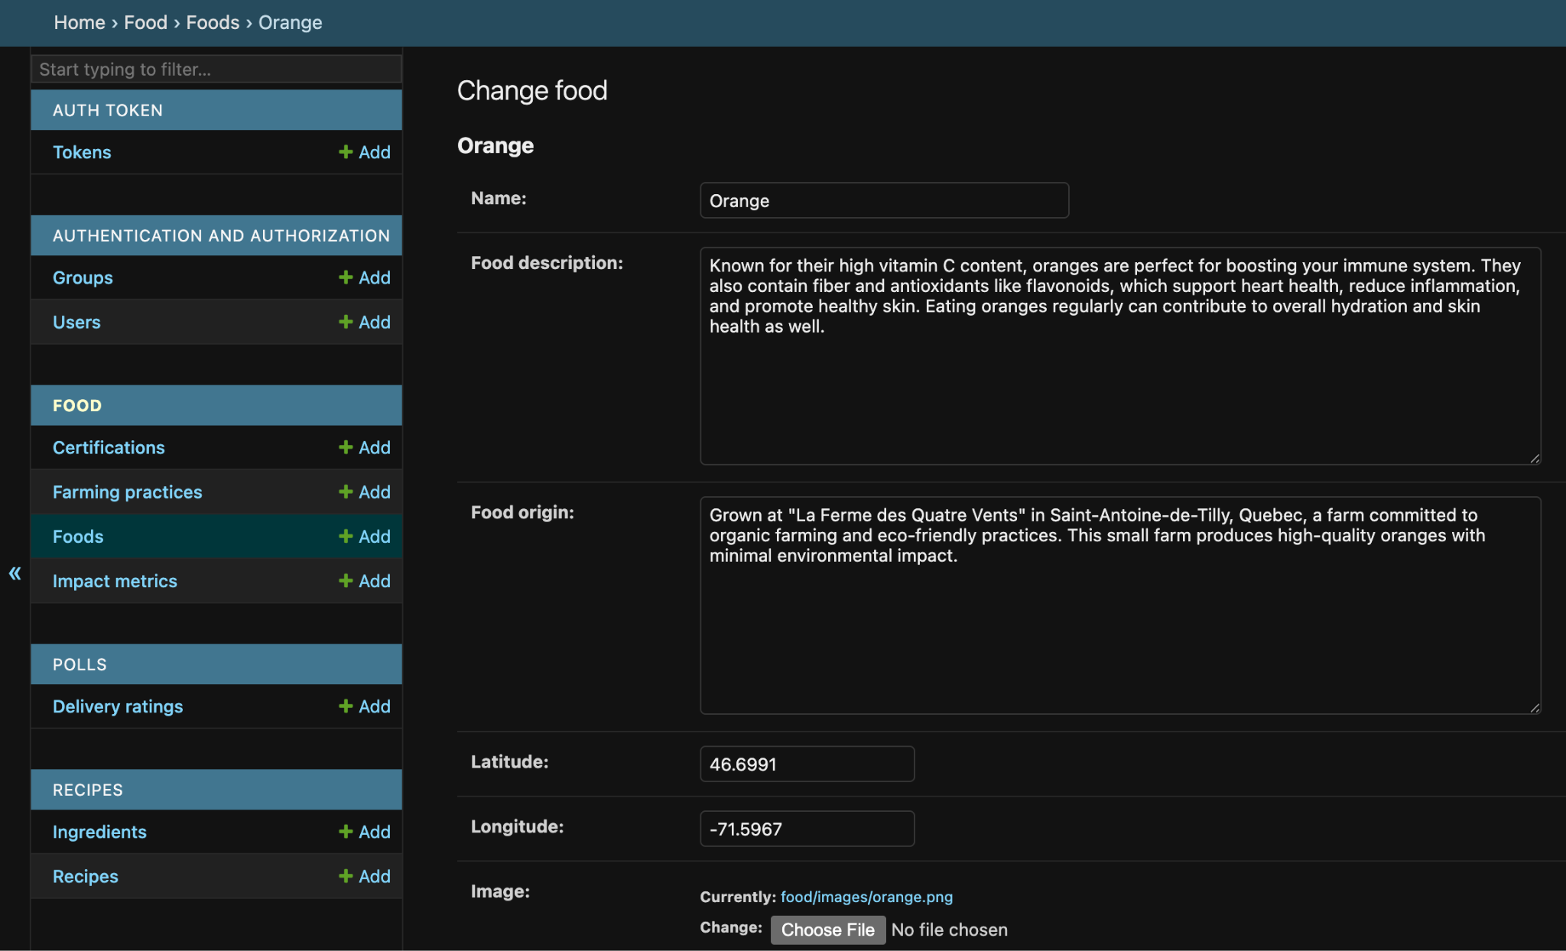

**If you log in with the wrong user:**

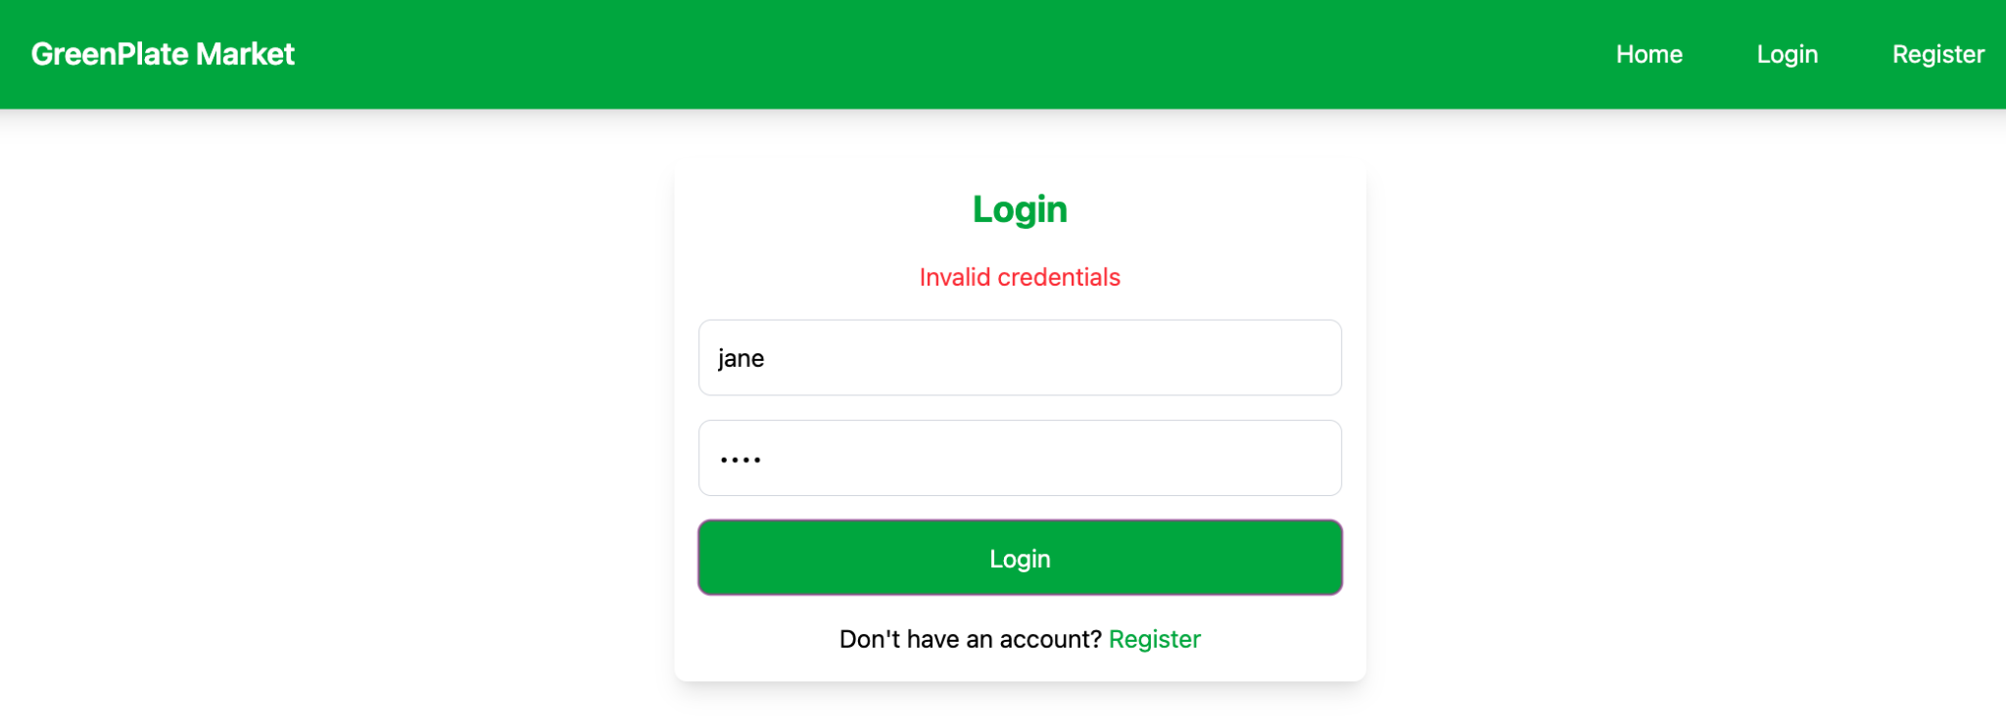

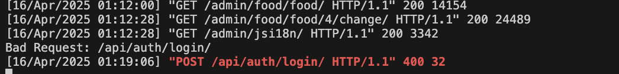

**If the user enter a location or season that doesn’t exist in the database**

An error is returned - “No ingredients found for the specified location and season”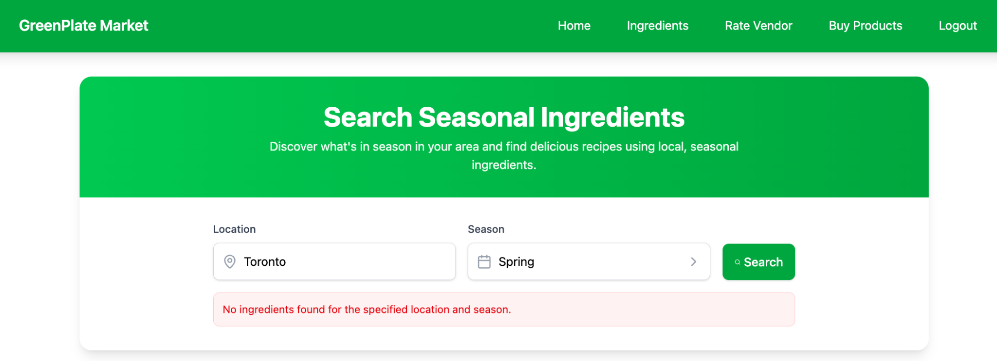

If no ingredients are found, a message will inform the user. This means the location and season are not in the database.

# **Test using ThunderClient:**

**Get request:(Ingredients)**

/api/ingredients/?location=Quebec&season=fall

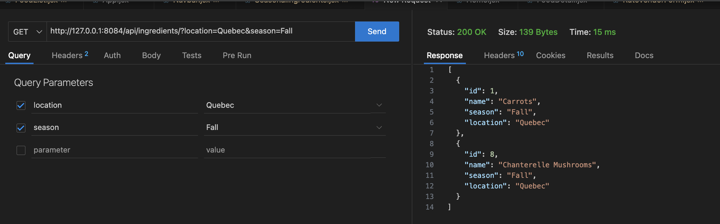

**Get request:(recipes)**

/api/recipes/?location=Quebec&season=fall

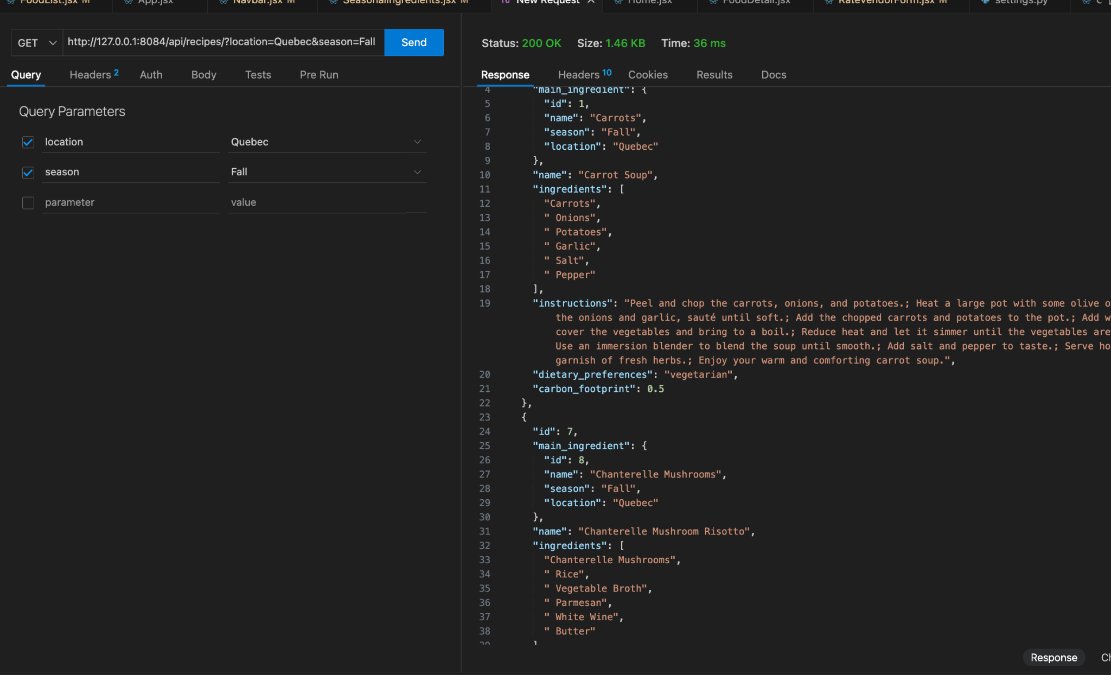

**Post request: (resister)**

/api/auth/register

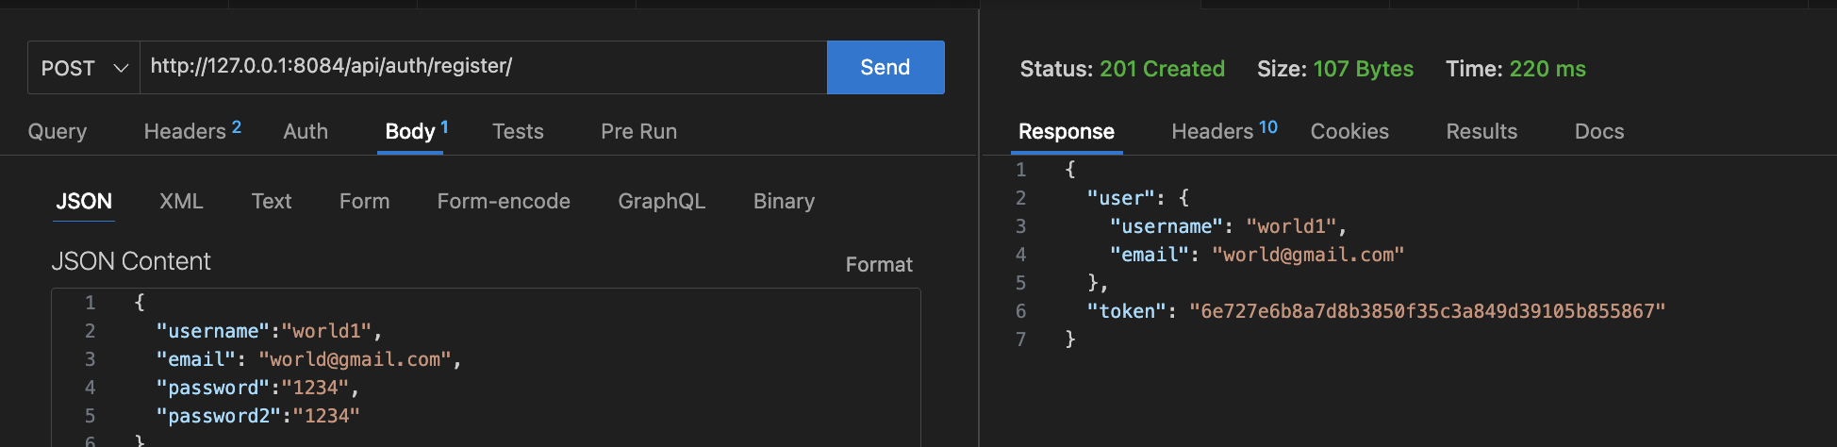

**Post request:**

/polls/delivery_rating

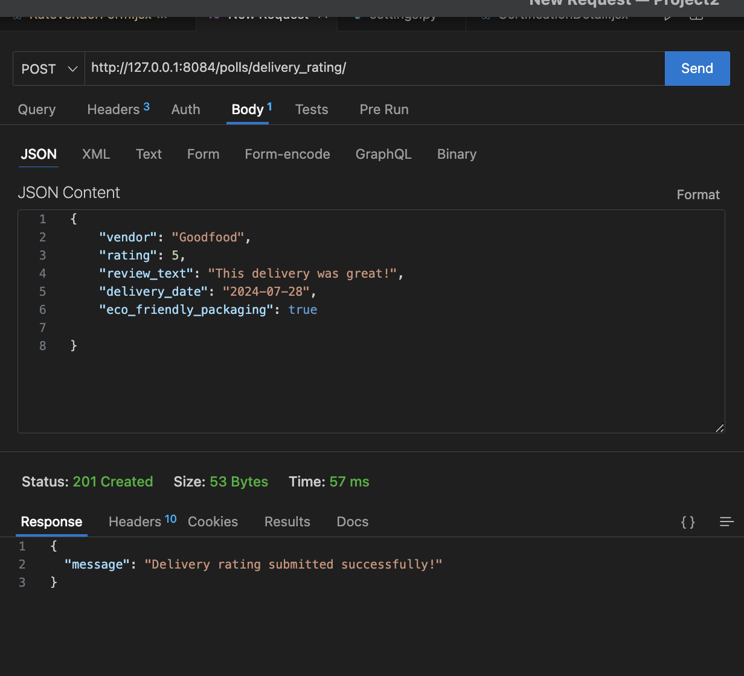

**Get request: All the ratings for the vendor**

/polls/api/ratings/

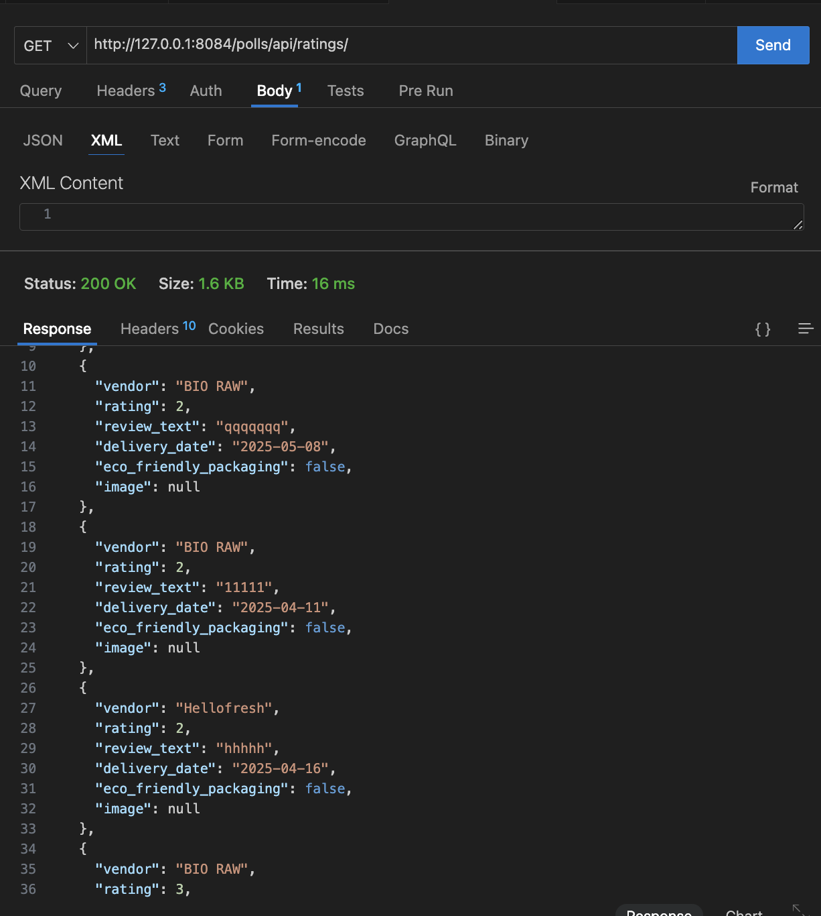

**Get request:(FoodProduct)**

/foods/apple

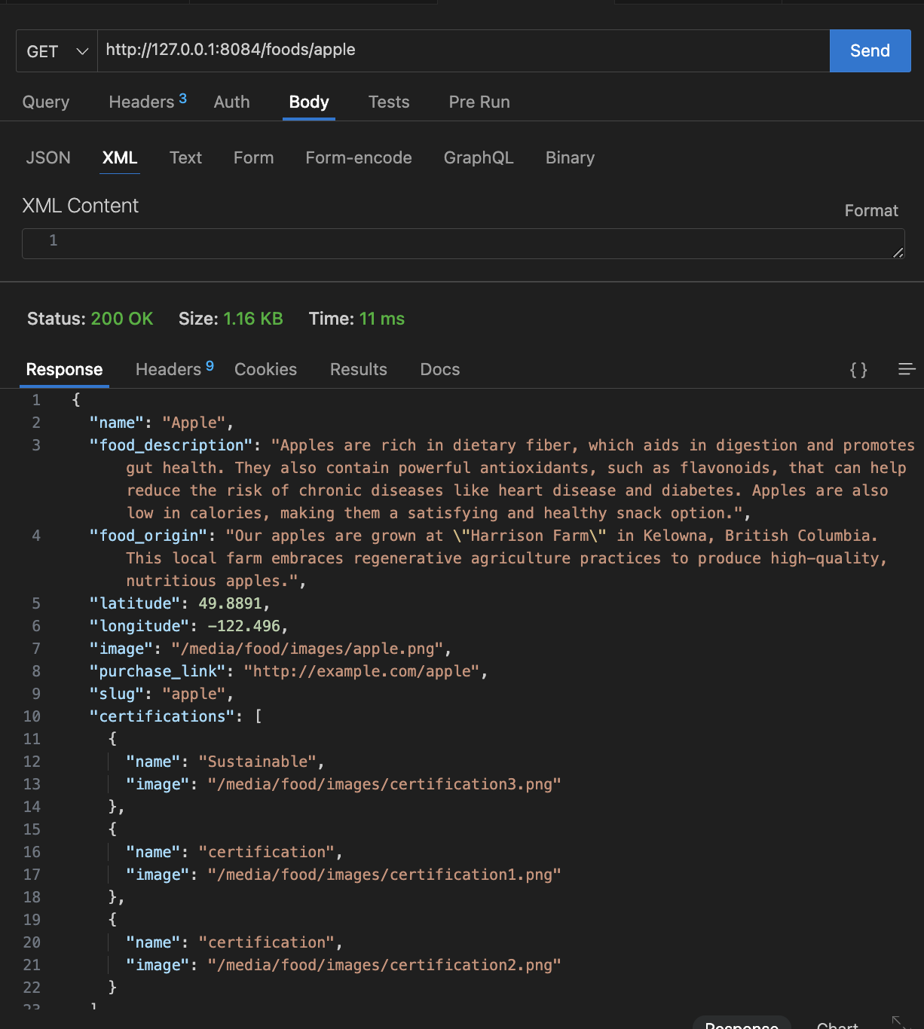

# **Automated Testing**

## **Register/Login**

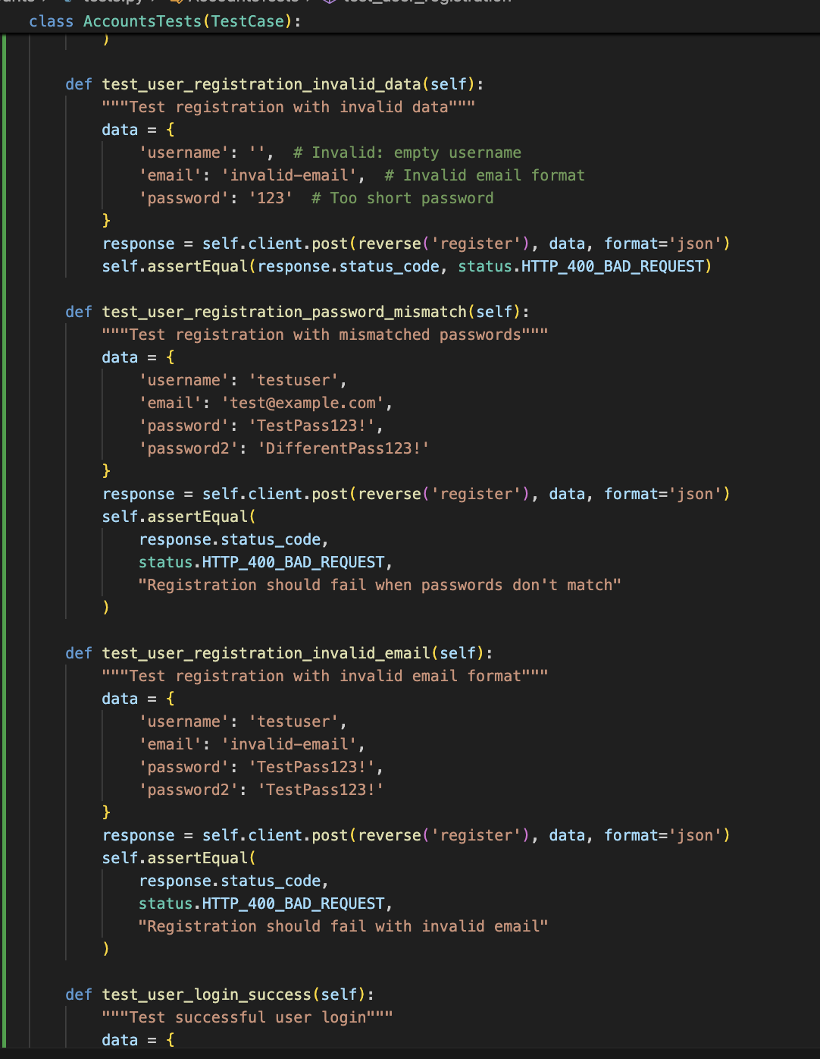

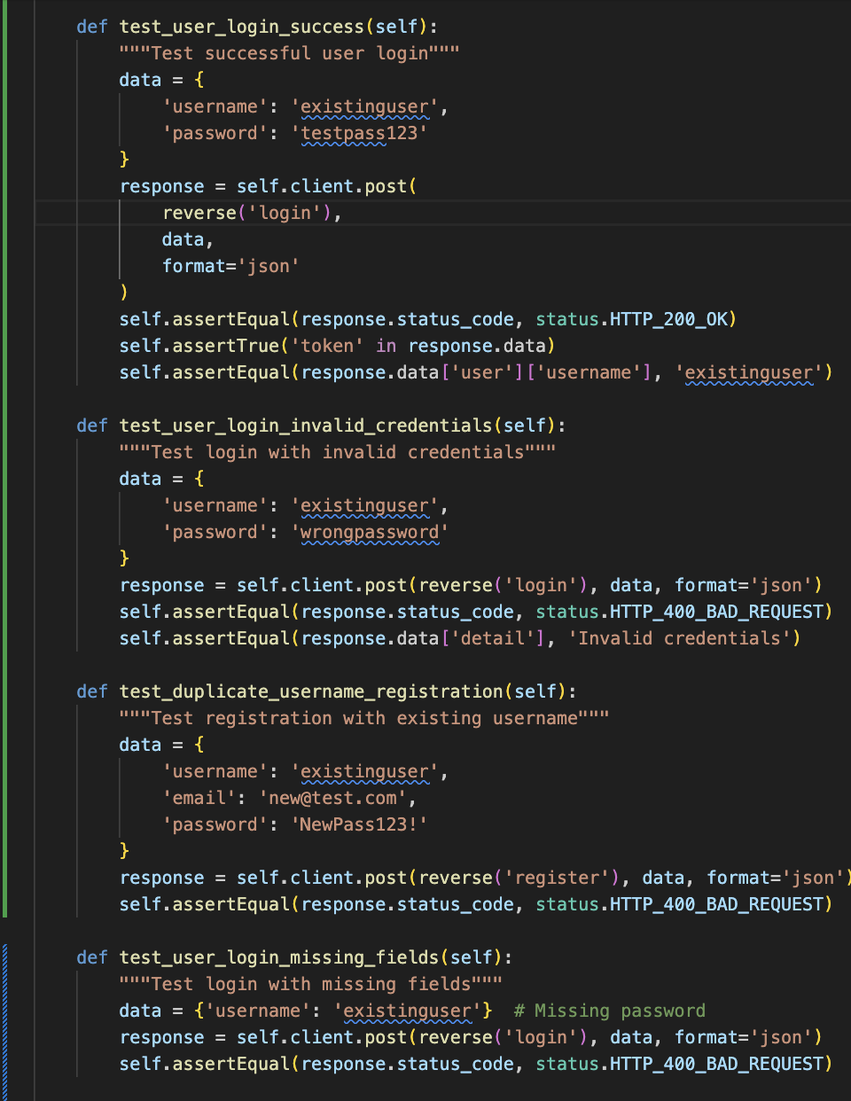

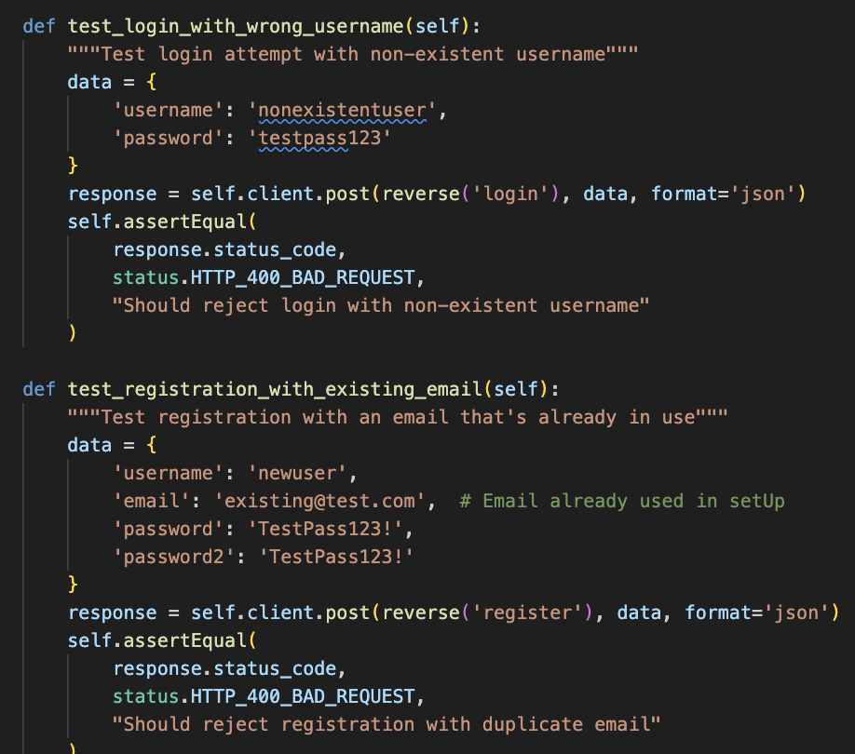

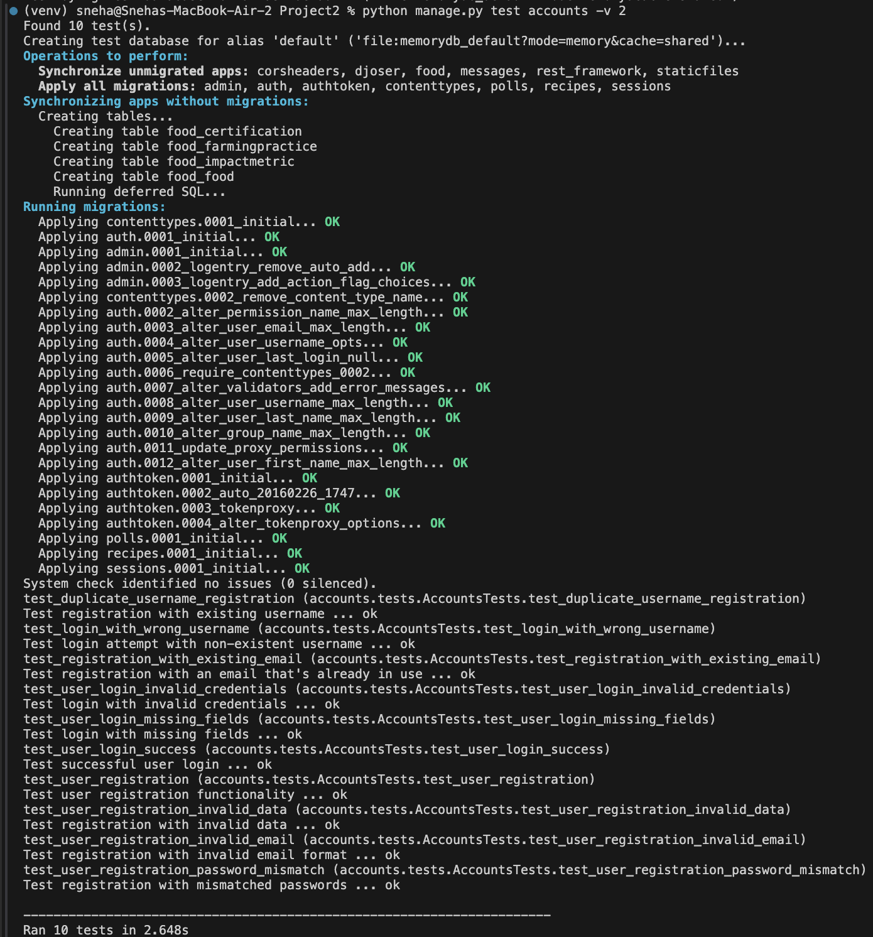

1. **Test Names:**

* test_duplicate_username_registration

1. Tests handling of duplicate usernames
2. Verifies: Rejects registration with existing username

* test_login_with_wrong_username

1. Tests login security for non-existent users
2. Verifies: Rejects login for non-existent username

* test_registration_with_existing_email

1. Tests email uniqueness validation
2. Verifies: Prevents duplicate email registration

* test_user_login_invalid_credentials

1. Tests login authentication
2. Verifies: Rejects wrong password

* test_user_login_missing_fields

1. Tests form validation
2. Verifies: Catches missing required fields

* test_user_login_success

1. Tests successful login flow
2. Verifies: Successful authentication, Token generation and User data in response

* test_usr_registration

1. Tests successful registration
2. Verifies: User creation Token generation

* test_user_registration_invalid_data

1. Tests input validation
2. Verifies: Empty username rejection, Invalid email format Password length requirements

* test_user_registration_invalid_email

1. Tests email format validation
2. Verifies: Rejects invalid email format

* test_user_registration_password_mismatch

1. Tests password confirmation
2. Verifies: Catches mismatched passwords

2. **Summary:**

* Total Tests Found: 10 tests
* All tests passed successfully
* Execution Time: 2.648 seconds
* Final Result: OK (all tests passed)
* Database: Created at start and destroyed after completione

## **Ingredients/Recipes**

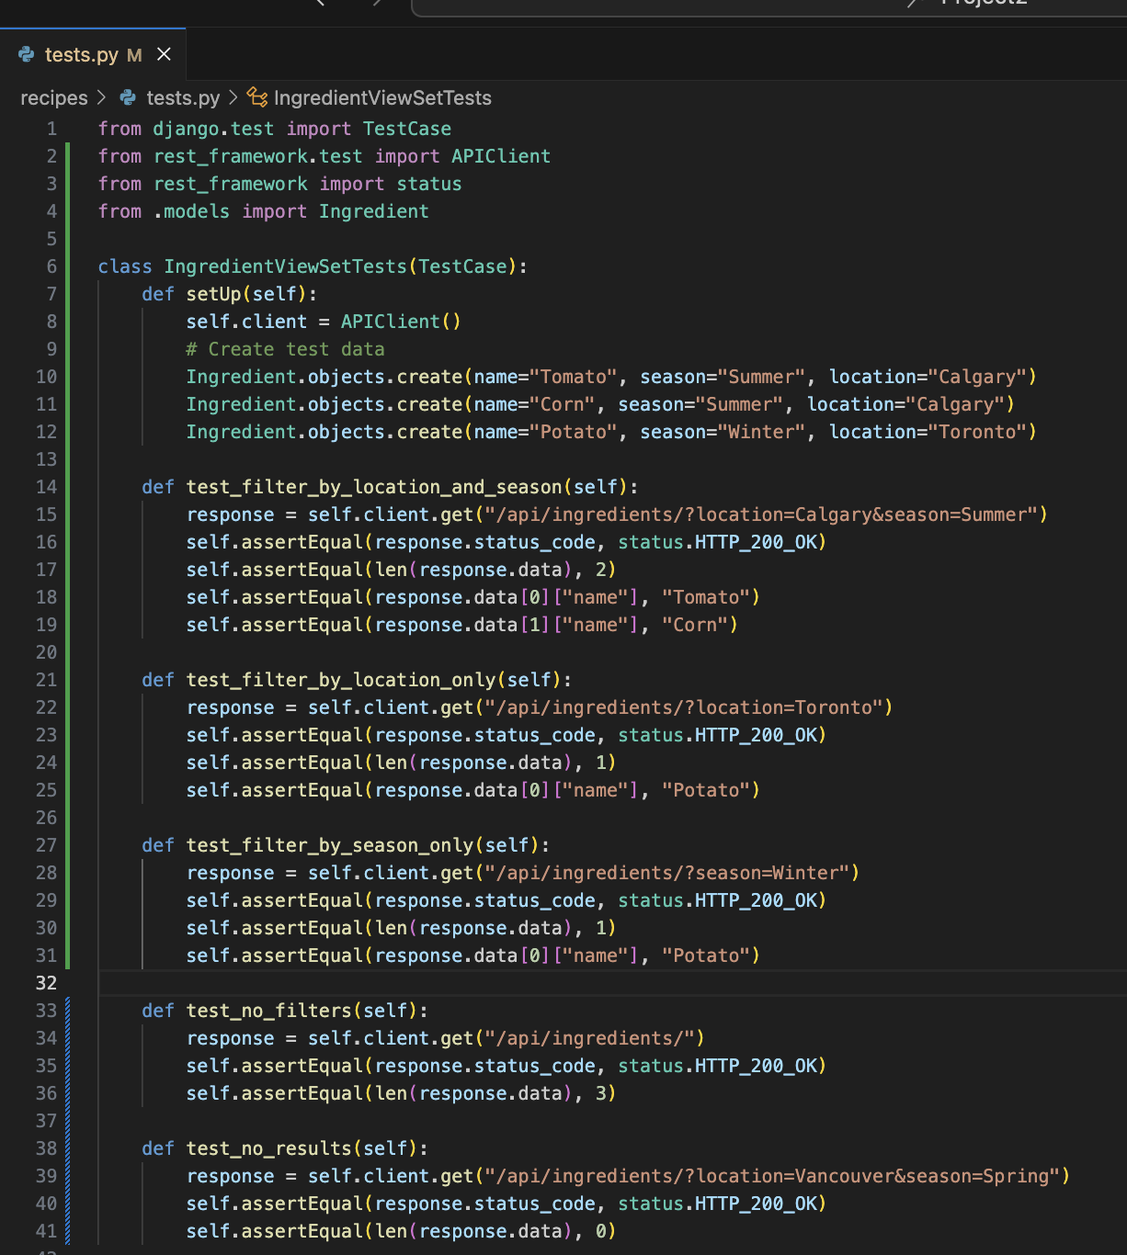

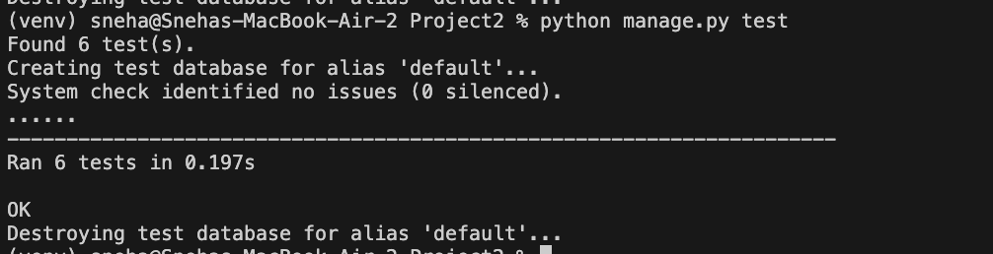

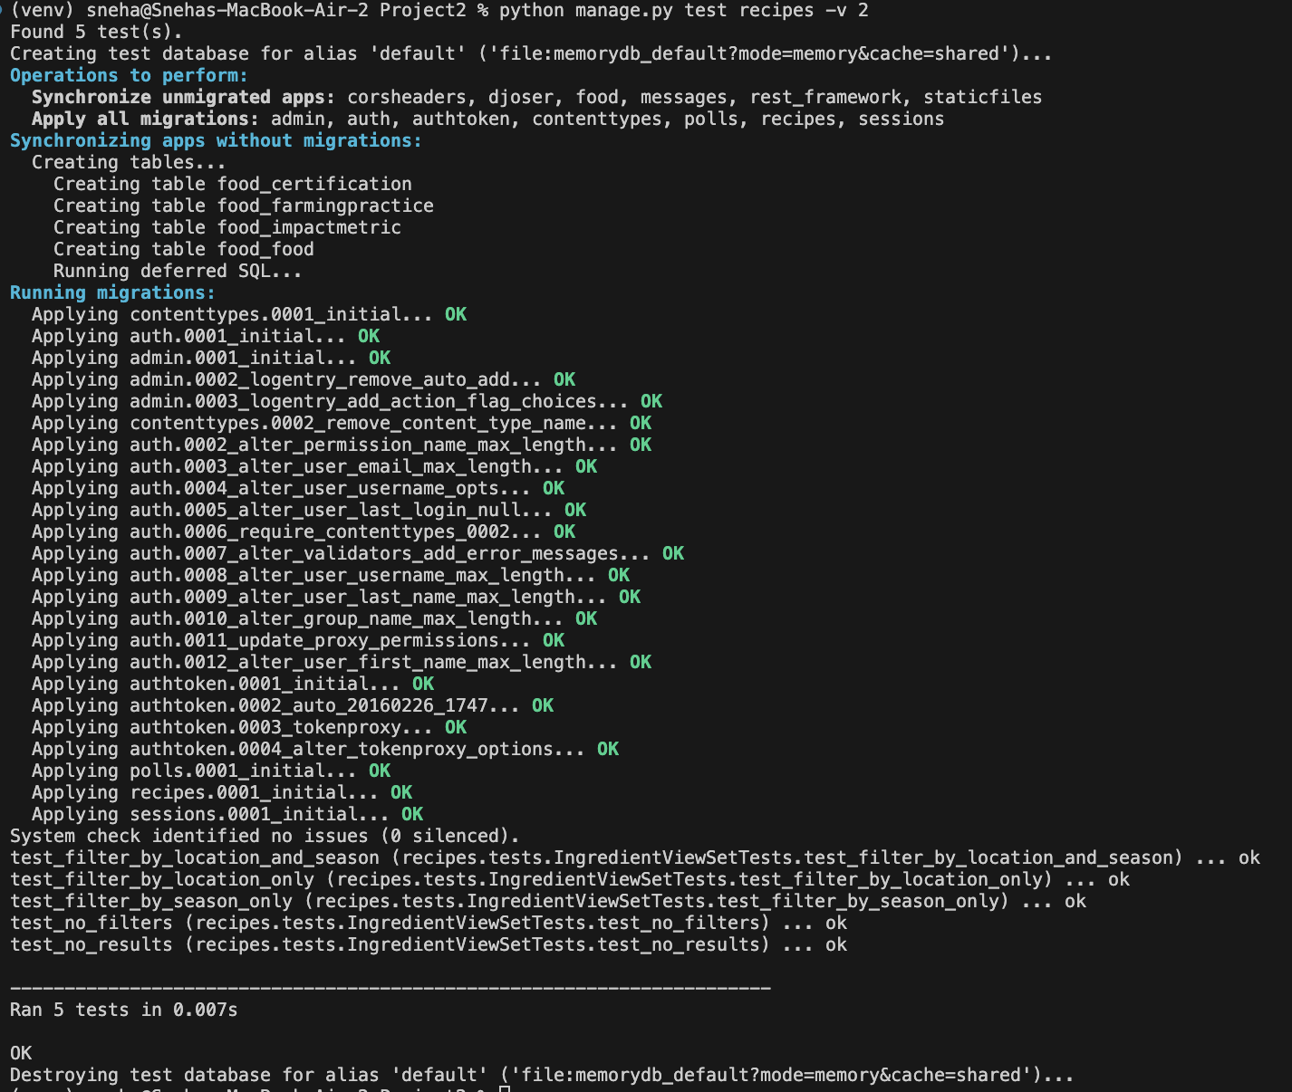

1. **Test Names:**

Each test case is listed with its full name from the IngredientViewSetTests class:

* test_filter_by_location_and_season

1. Tests filtering ingredients by both location and season
2. Verifies: Returns ingredients for Calgary in Summer and contains exactly 2 ingredients

* test_filter_by_location_only

1. Tests filtering ingredients by location only
2. Verifies: Returns ingredients for Toronto and contains exactly 1 ingredient

* test_filter_by_season_only

1. Tests filtering ingredients by season only
2. Verifies: Returns ingredients for the Winter season. Contains exactly 1 ingredient

* test_no_filters

1. Tests retrieving all ingredients without filters
2. Verifies: Returns all ingredients

* test_no_results

1. Test behavior when no ingredients match filters
2. Verifies: Returns an empty list
3. **Custom Messages:**

* The custom messages added to the msg parameter in the assertions are displayed alongside the test name.
* For example, the expected status code is 200 for filtering by location and season.

1. **Result for Each Test:**

* ... ok: Indicates that the test passed successfully.
* If a test fails, it will display FAIL or ERROR along with the reason..

1. **Summary:**

* Total Tests Found: 5 tests
* Total Tests Run: 5 tests Execution
* Time: 0.007 seconds
* Result: All tests passed (OK)
* Test Database: Created at start and destroyed at end

## **FoodProducts**

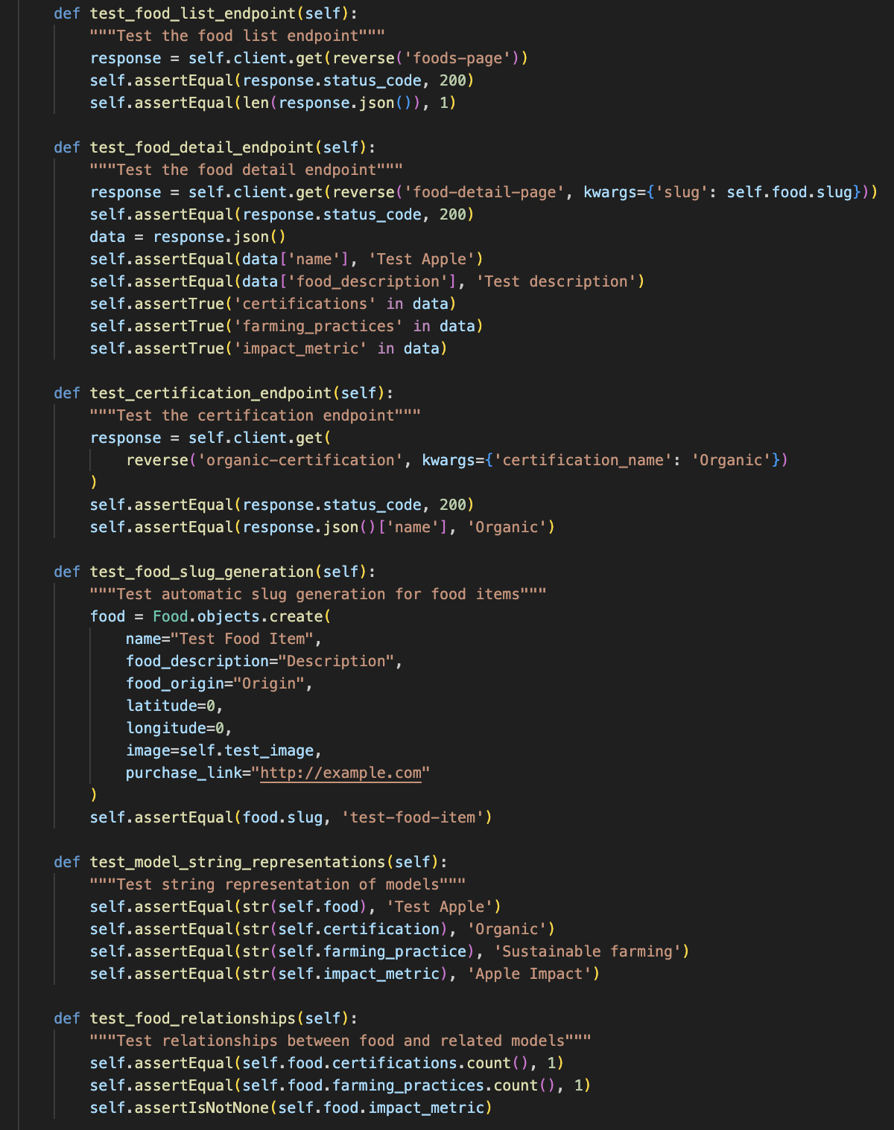

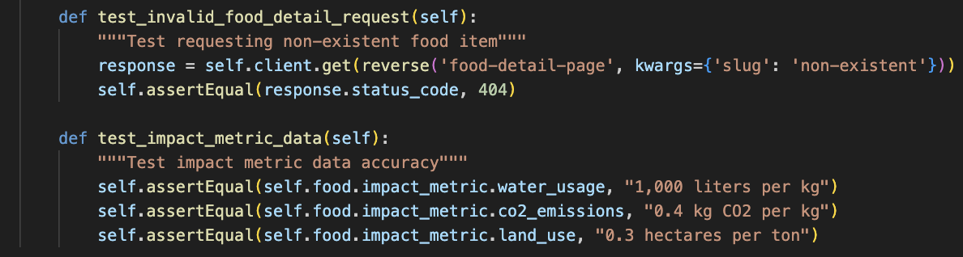

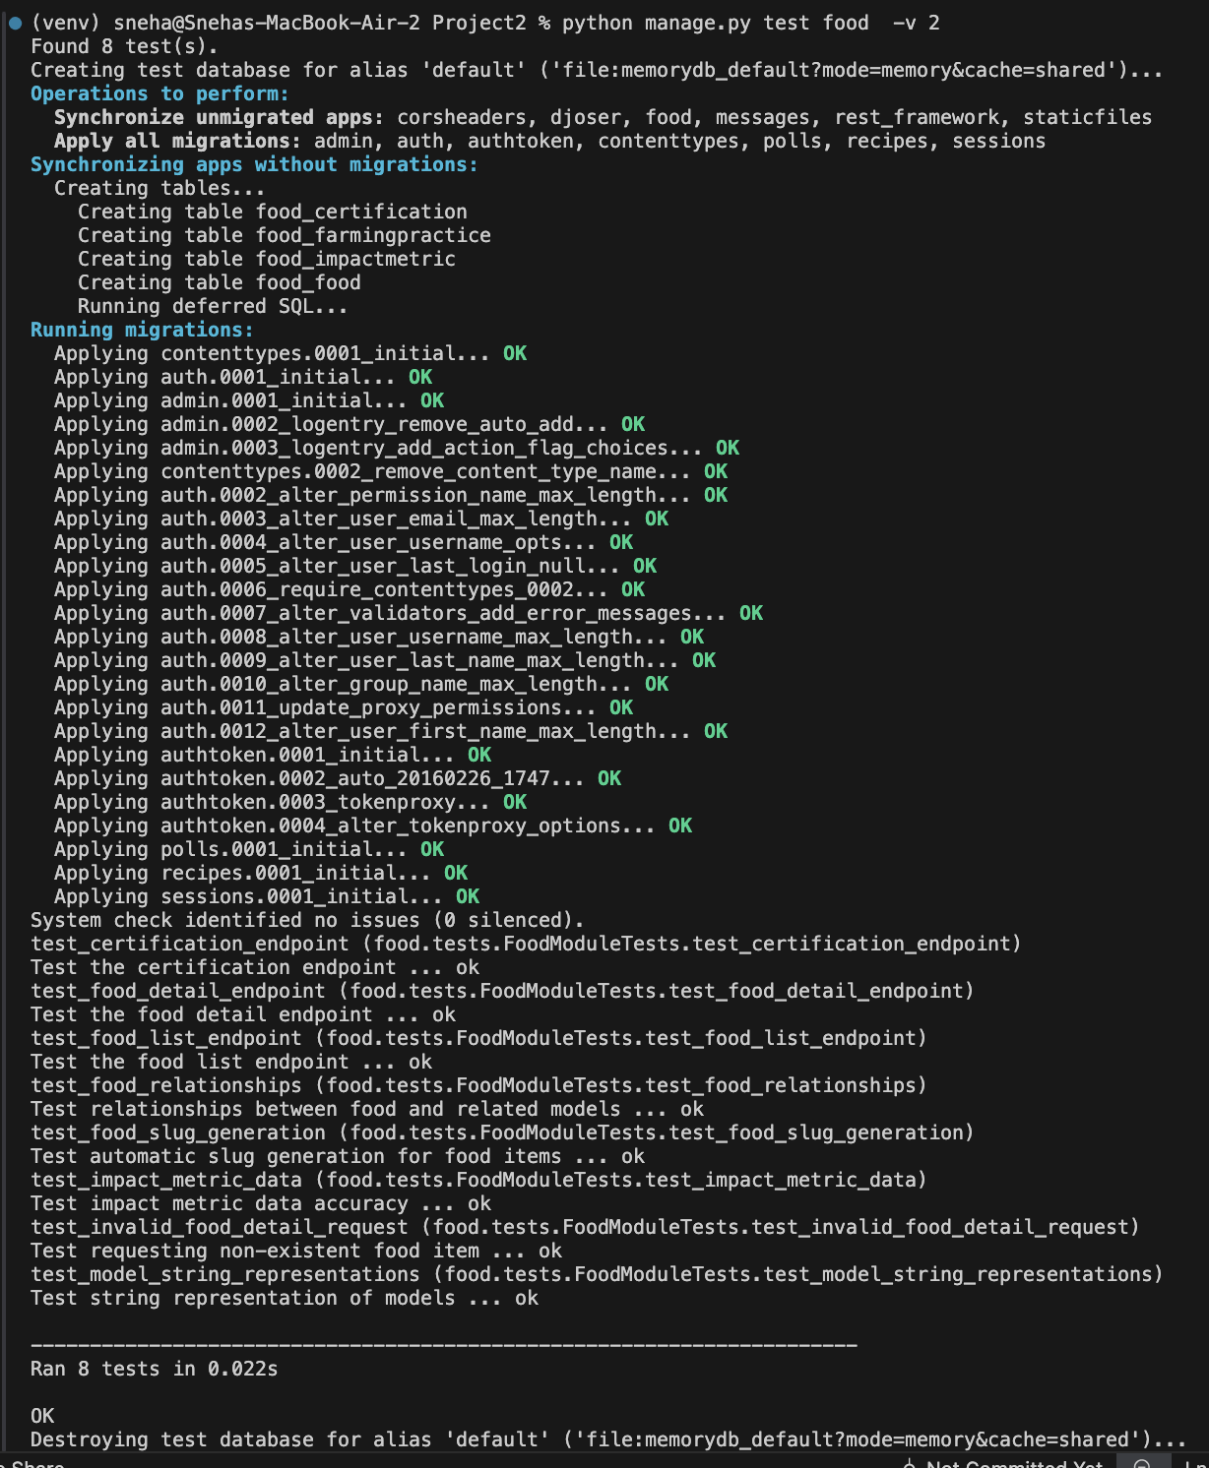

1. **Test Names:**

* test_food_list_endpoint

1. Tests the API endpoint that lists all foods
2. Verifies: Response status is 200 (OK) Response contains 1 food item (Test Apple)

* test_food_detail_endpoint

1. Tests getting details of a specific food item
2. Verifies: Response status is 200, Correct food name and description, Presence of certifications, farming practices, and impact metrics

* test_certification_endpoint

1. Tests retrieving certification information
2. Verifies: Response status is 200, Correct certification name ("Organic")

* test_food_slug_generation

1. Test automatic URL-friendly slug creation
2. Verifies "Test Food Item" becomes "test-food-item"

* test_model_string_representations

1. Test how models are displayed as strings
2. Verifies correct string format

for: Food items, Certifications, Farming practices, Impact metrics

* test_food_relationships

1. Test relationships between models
2. Verifies: Food has one certification, one farming practice, and has impact metrics.

* test_invalid_food_detail_request

1. Test error handling.
2. Verifies 404 status for non-existent food items.

* test_impact_metric_data:

1. Tests the accuracy of impact metrics.
2. Verifies correct: Water usage data, CO2 emissions data
3. **Custom Messages:**

* The custom messages added to the msg parameter in the assertions are displayed alongside the test name.

1. **Result for Each Test:**

* ... ok: Indicates that the test passed successfully.
* If a test fails, it will display FAIL or ERROR along with the reason. In this case, the test passed without any issues.

1. **Summary:**

* Total Tests Found: 8 tests Execution
* Time: 0.022 seconds
* Result: All tests passed (OK)
* Test Database: Created at start and destroyed at end

## **RateVendor/Polls**

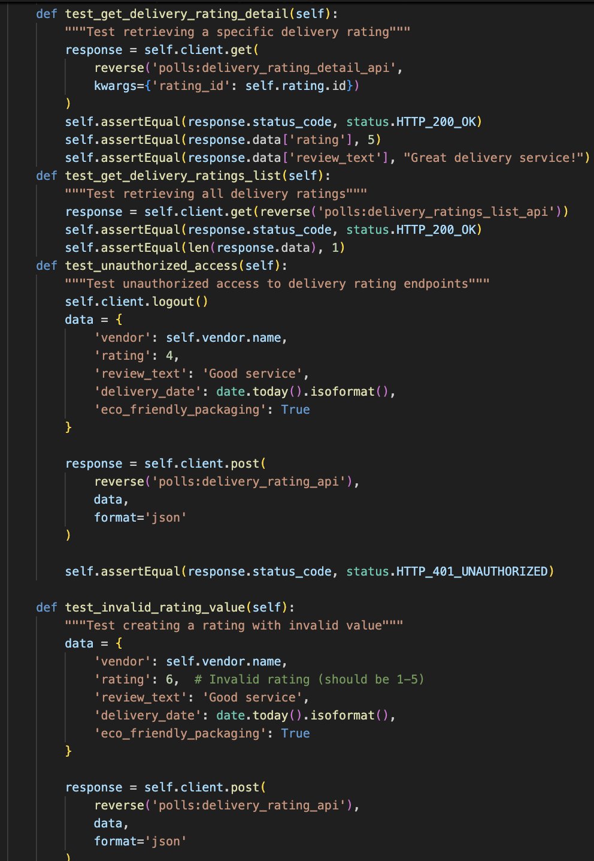

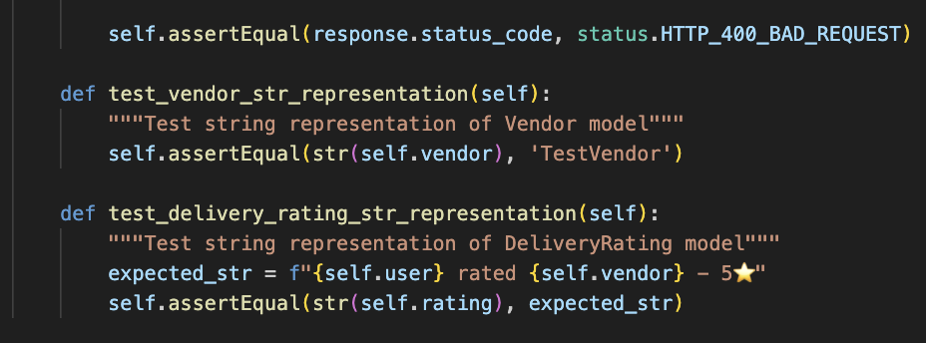

After running the test, we get,

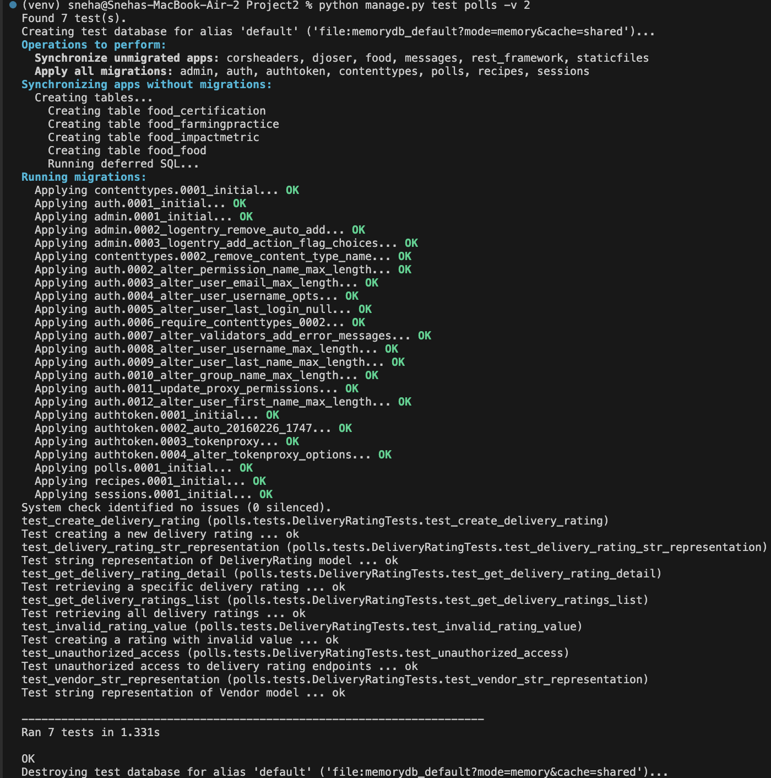

1. **Test Names:**

Each test case is listed with its full name from the DeliveryRatingTests class:

* test_create_delivery_rating

1. Tests the creation of a new delivery rating
2. Verifies: Successfully creates new rating

* test_delivery_rating_str_representation

1. Tests how delivery ratings are displayed as strings

* test_get_delivery_rating_detail

1. Tests retrieving specific rating details

* test_get_delivery_ratings_list

1. Tests retrieving the ratings list

* test_invalid_rating_value

1. Tests the handling of invalid rating values
2. Invalid data doesn't get stored

* test_unauthorized_access

1. Test security for unauthorized users
2. Protected endpoints are secure

* test_vendor_str_representation

1. Test vendor name display format,
2. Vendor name displays correctly.

2. **Custom Messages:**

Each test includes descriptive messages:

* Test creating a new delivery rating
* Test the string representation of the DeliveryRating model
* Test retrieving a specific delivery rating
* Test unauthorized access to delivery rating endpoints

3. **Result for Each Test:**

All tests passed successfully:

* ... ok, after each test name indicates successful execution
* No FAIL or ERROR messages present
* All assertions within each test passed

4. **Summary:**

* Total Tests Run: 7 tests Execution
* Time: 1.331 seconds
* All tests passed (OK)
* Test Database: Created at start and destroyed at end